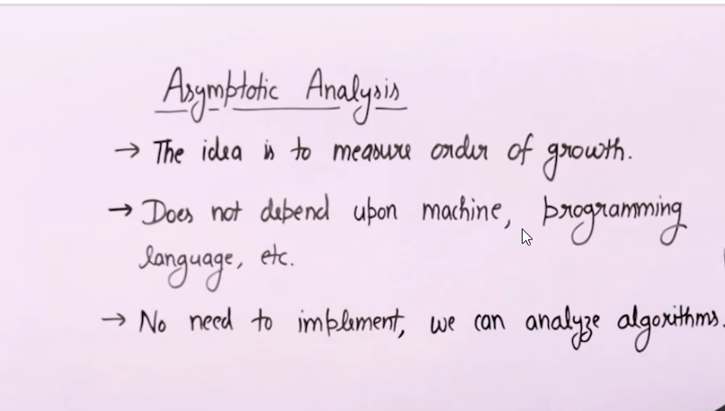

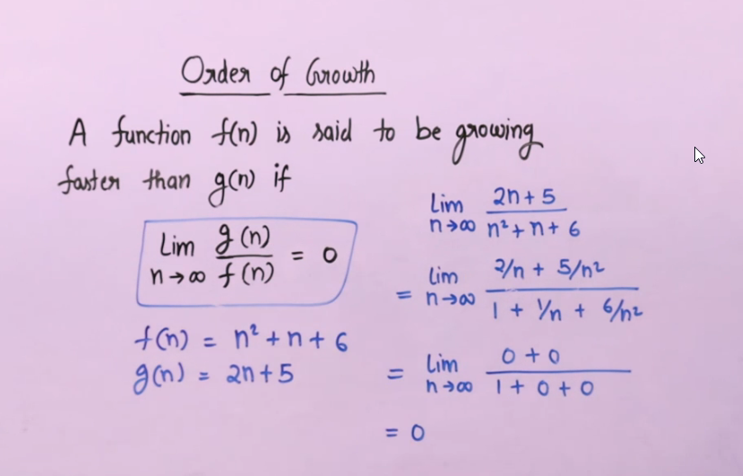

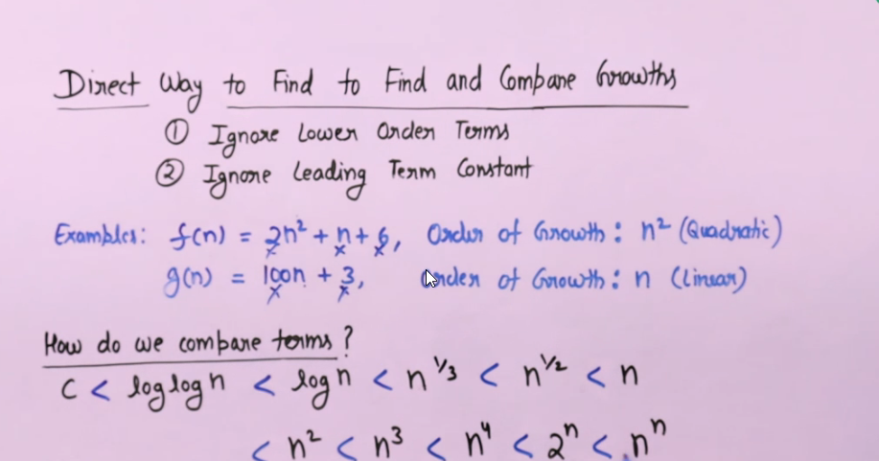

Asymptotic Notation is the mathematical notation representing order of growth of any mathematical function.

Types of Asymptotic notation

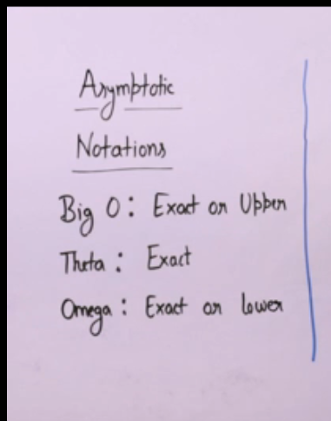

Big O Notation is used to represent the upper bound or higher order of growth.

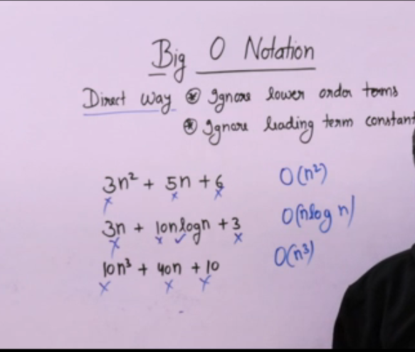

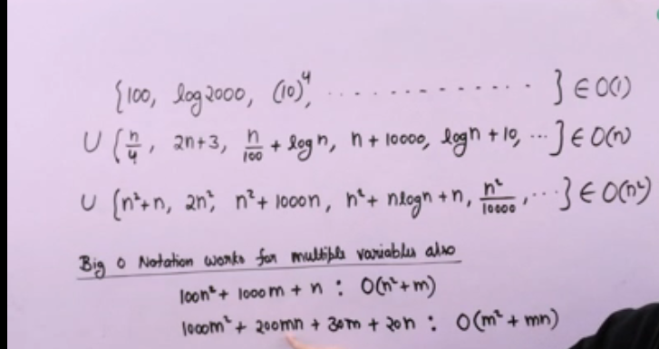

O(1) – it it used to denote constant time.

Omega Notation – It is used when we have lower bound i.e it tells about the minimum time an algorithm will take to complete it’s execution. Big - Ω notation is the least used notation for the analysis of algorithms because it can make a correct but imprecise statement over the performance of an algorithm. Suppose a person takes 100 minutes to complete a task, using Ω notation, it can be stated that the person takes more than 10 minutes to do the task, this statement is correct but not precise as it doesn't mention the upper bound of the time taken.

Theta Notation – It is used to represent the exact bound of a function or algorithm. It bounds the function from both sides. So both the function should have same order of growth.

In simple language, Big - Theta(Θ) notation specifies asymptotic bounds (both upper and lower) for a function f(n) and provides the average time complexity of an algorithm.

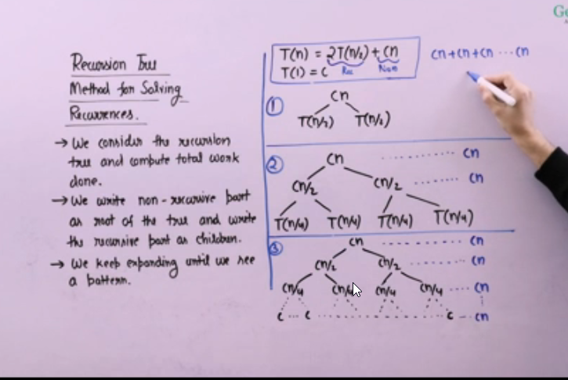

Space Complexity is defined as order of growth of memory space or RAM space in terms of it’s input size. *Auxiliary Space* is the extra space or temporary space used by an algorithm.   
  
*Space Complexity*of an algorithm is the total space taken by the algorithm with respect to the input size. Space complexity includes both Auxiliary space and space used by input.

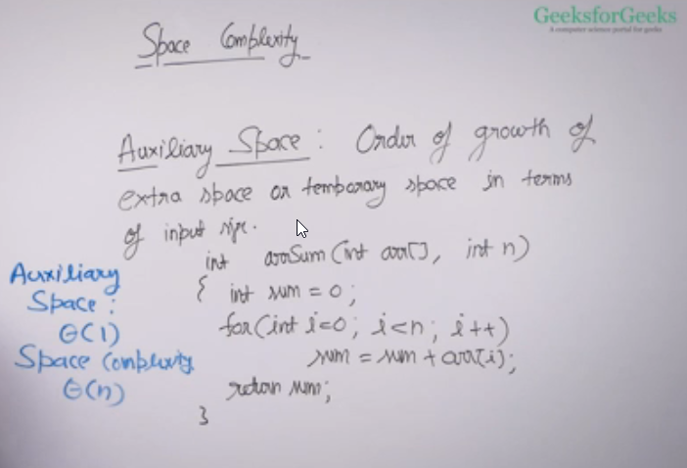

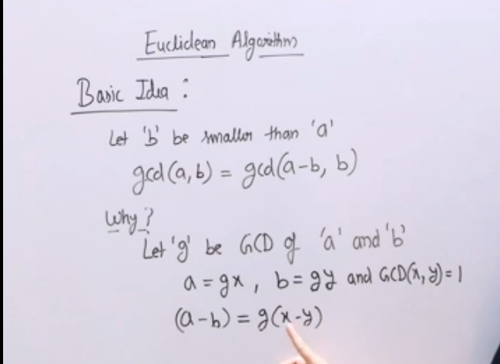

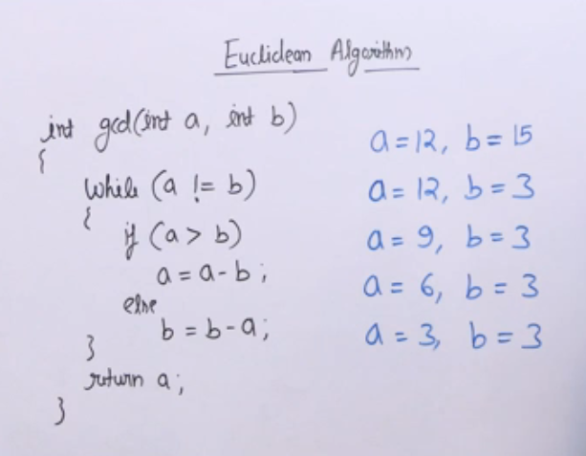

Optimized version

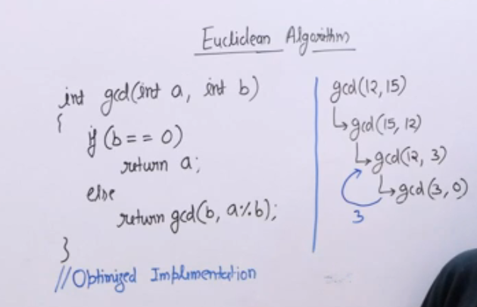

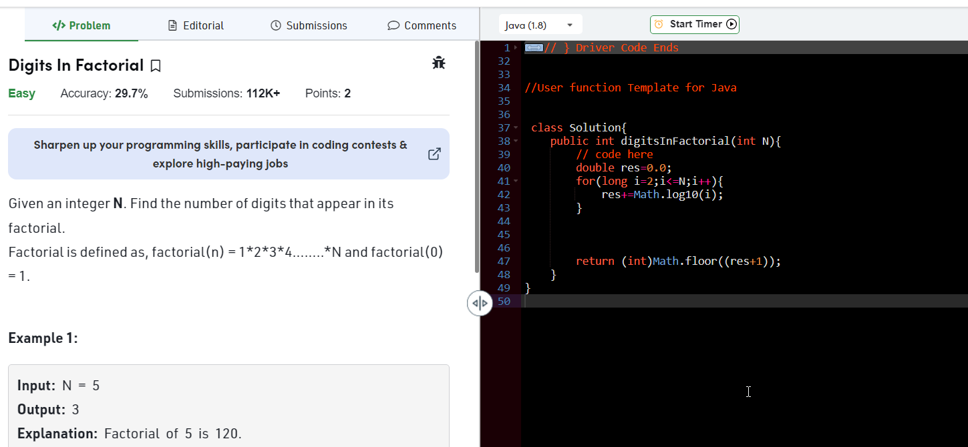

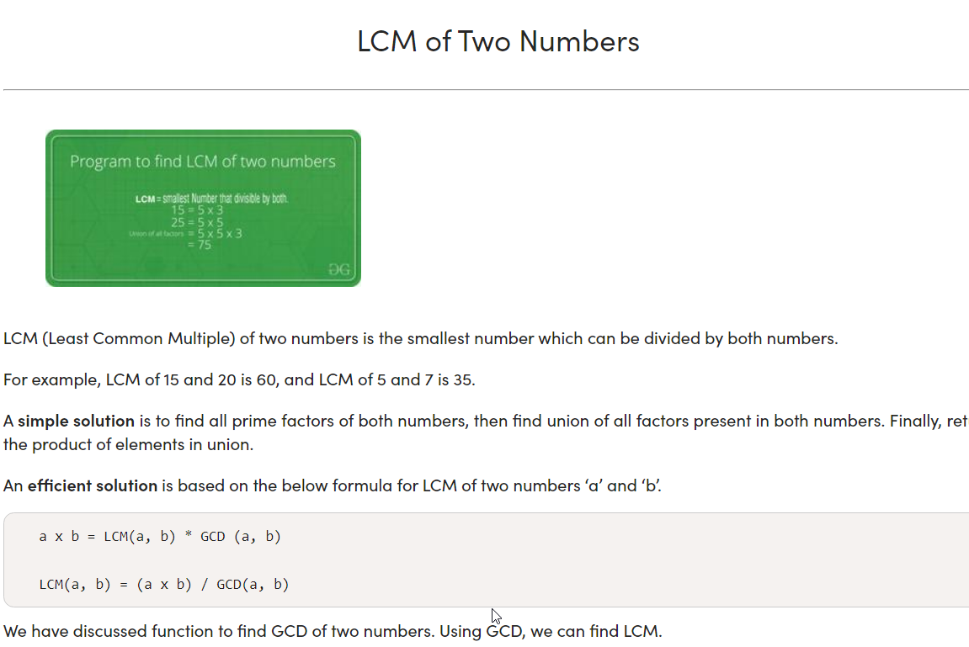

Find number of trailing zeroes in a factorial

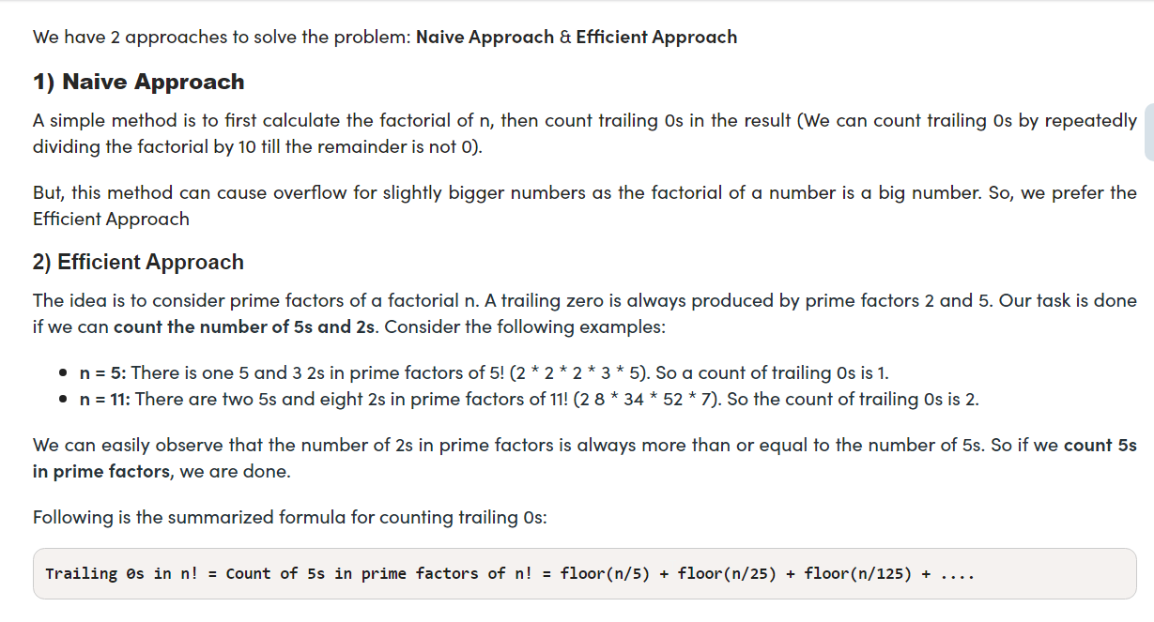

Alternative approach(Repeatedly divide the number by 5 and store the quotient in a variable)

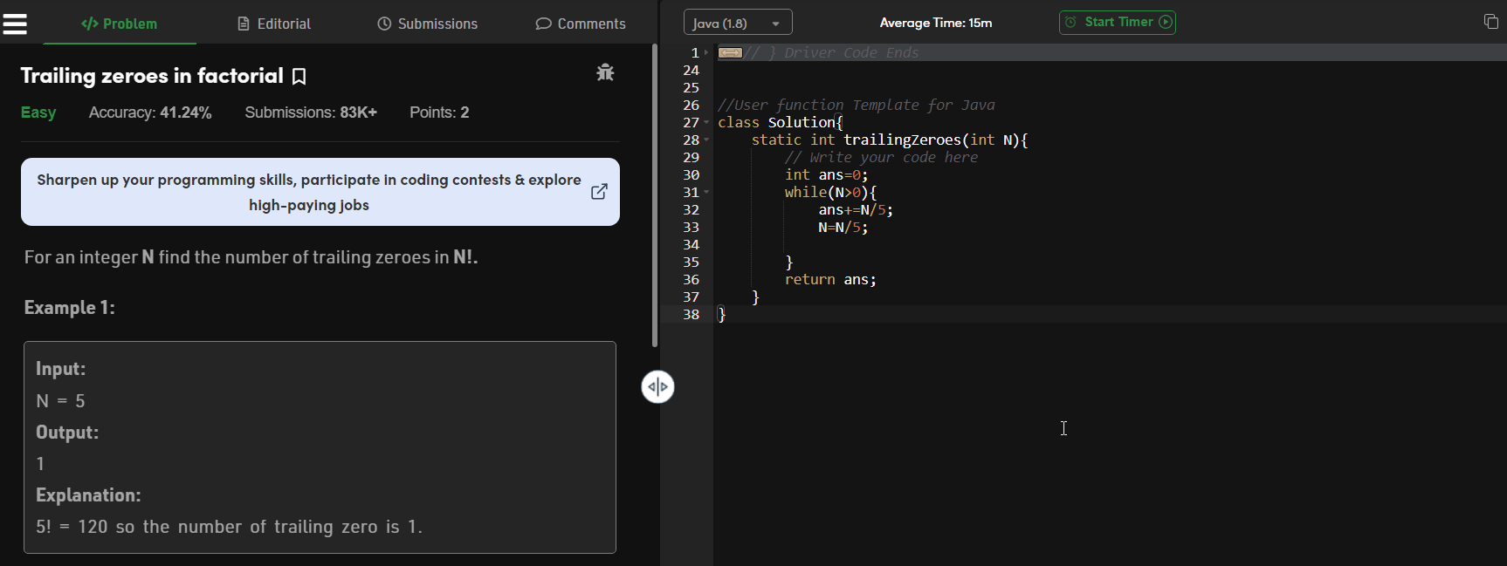

Check Prime Number

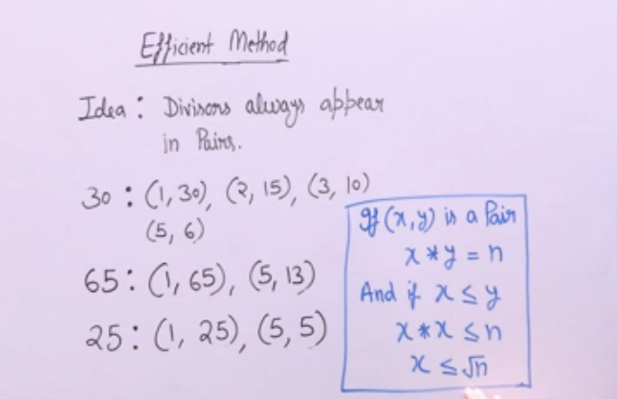

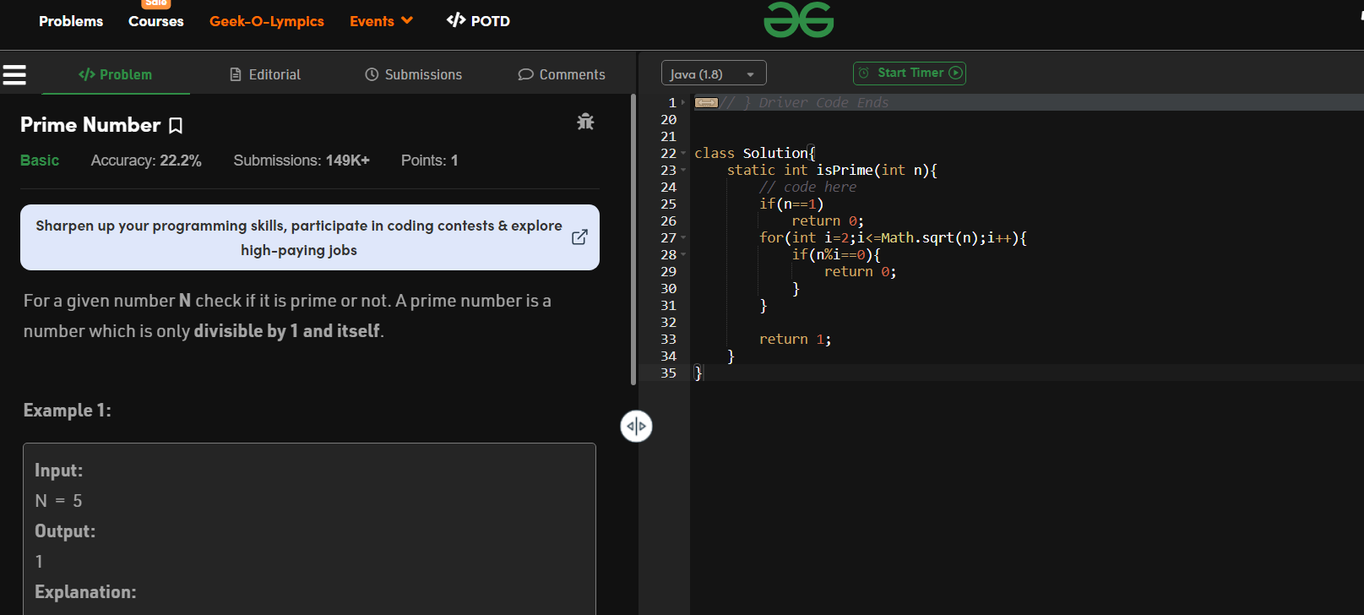

Time Complexity of above solution would be O(SquareRoot Of N).

More Efficient Approach

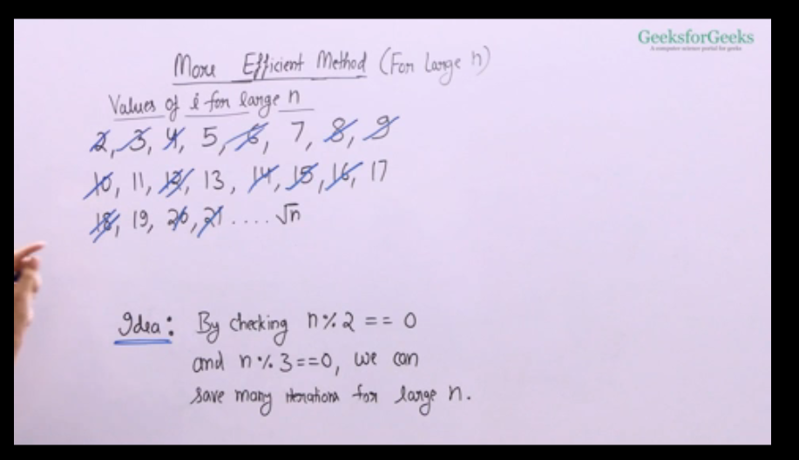

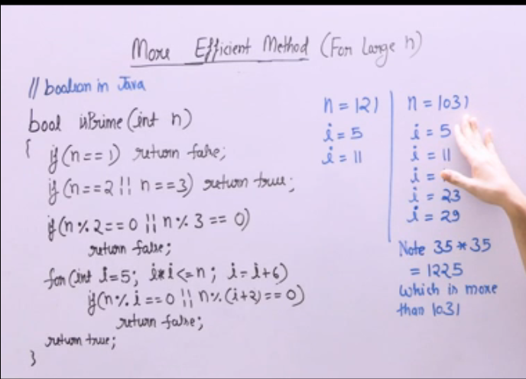

Efficient Solution to print prime factors of a number

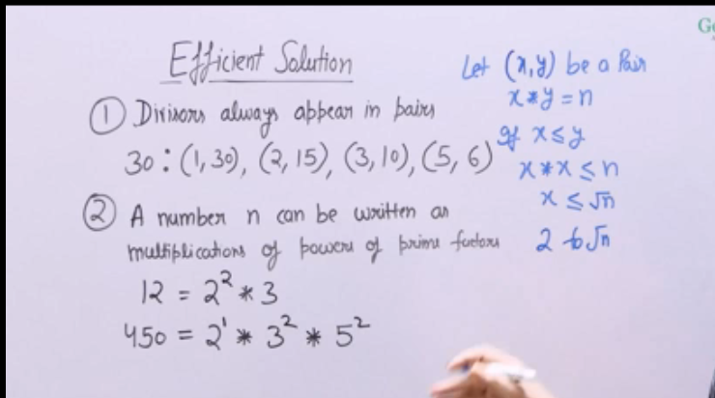

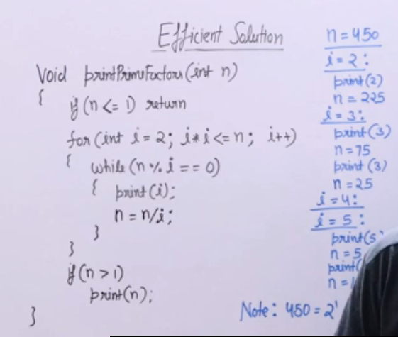

In the above solution, we are running a loop sqrt(n) time and dividing the number n by i every time to reduce it.

And the last condition n>1 is added, in cases when the reduced value of n will be prime number(Example -84 in this case it is 2^2*3*7)

All Divisors of a Number (Efficient Approach).

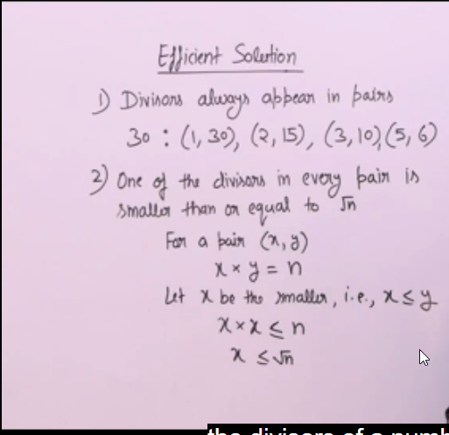

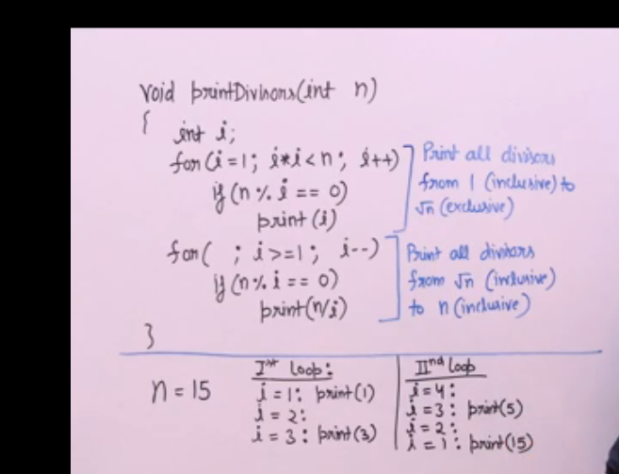

Sieve of Eratosthenes

The sieve of Eratosthenes is one of the most efficient ways to find all primes smaller than n when n is smaller than 10 million or so.

Following is the algorithm to find all the prime numbers less than or equal to a given integer n by the Eratosthene’s method:   
When the algorithm terminates, all the numbers in the list that are not marked are prime.

**Explanation with Example:**

Let us take an example when n = 50. So we need to print all prime numbers smaller than or equal to 50.

We create a list of all numbers from 2 to 50.

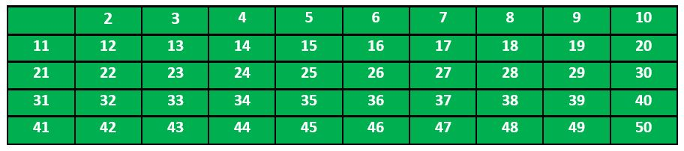

According to the algorithm we will mark all the numbers which are divisible by 2 and are greater than or equal to the square of it.

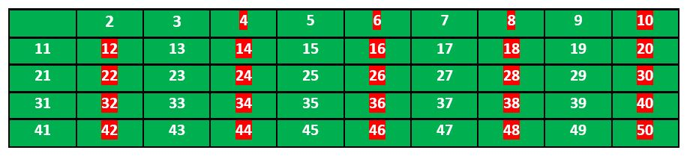

Now we move to our next unmarked number 3 and mark all the numbers which are multiples of 3 and are greater than or equal to the square of it.

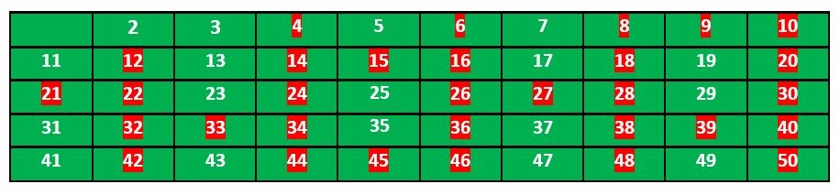

We move to our next unmarked number 5 and mark all multiples of 5 and are greater than or equal to the square of it.

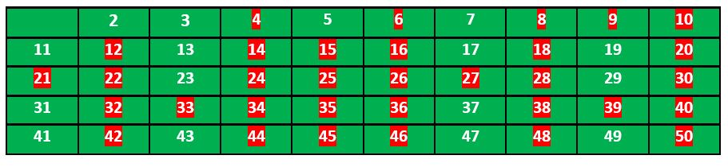

We continue this process and our final table will look like below:

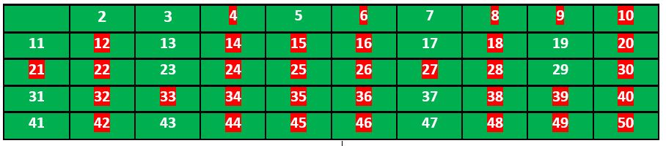

So the prime numbers are the unmarked ones: 2,3, 5, 7, 11, 13, 17, 19, 23, 29, 31, 37, 41, 43, 47.

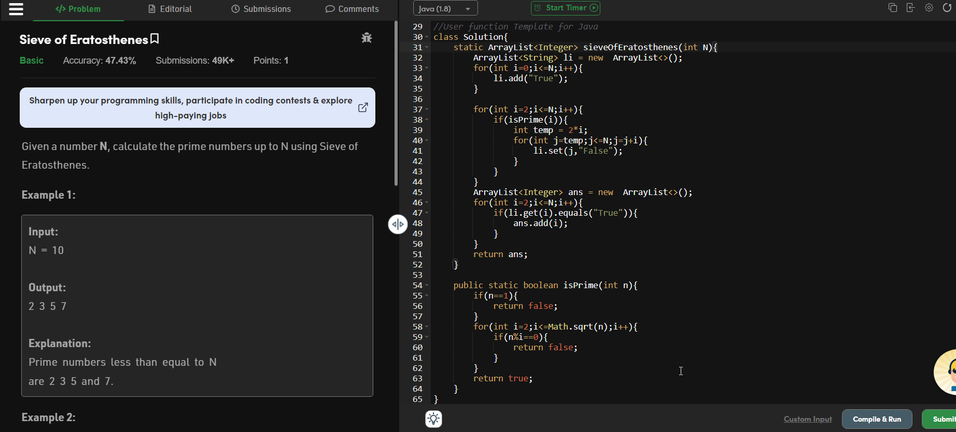

Compounding power

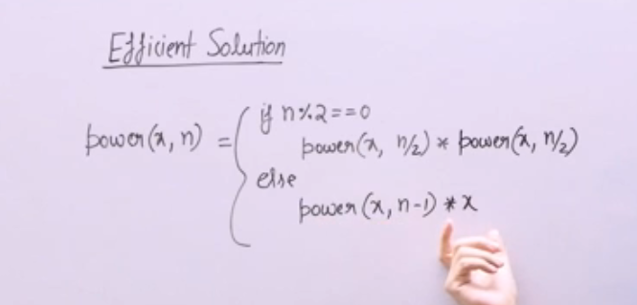

Alternative to Math.pow(x,n)

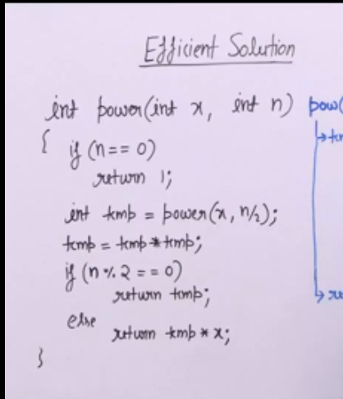

Bitwise Operator in java

And Opeartor

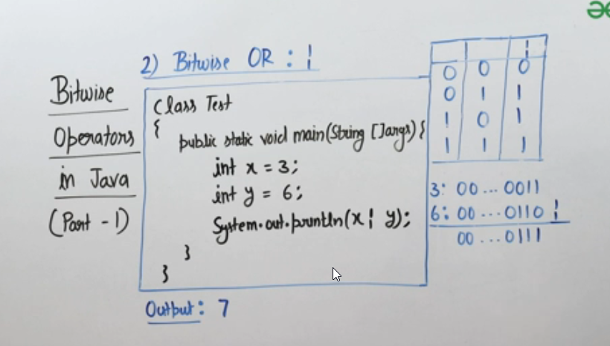

Bitwise XOR operator



Bitwise Not Operator

It converts positive numbers to negative numbers.

Positive numbers have leading bits as 0, Negative numbers have leading bits as 1.

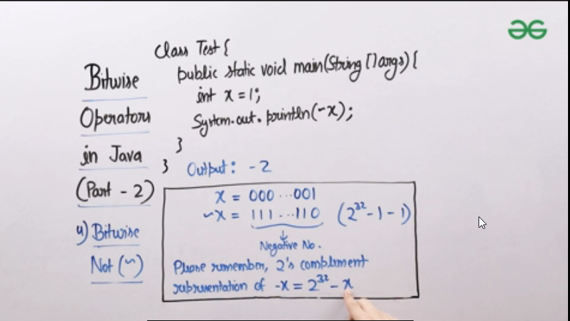

If all the bits are 1 then that number is 2^32-1.

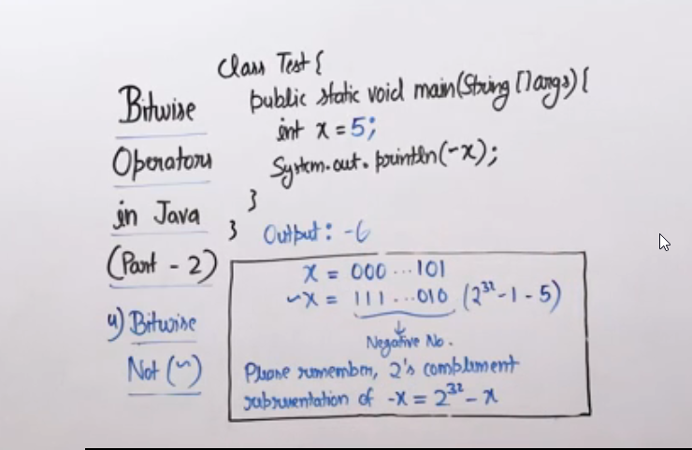

If all bits are negative then we subtract 2^32-1-x

The output in such cases are -1-x.

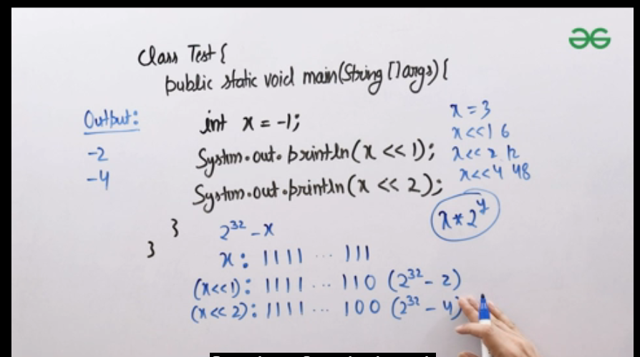

Signed Right Shift Operator

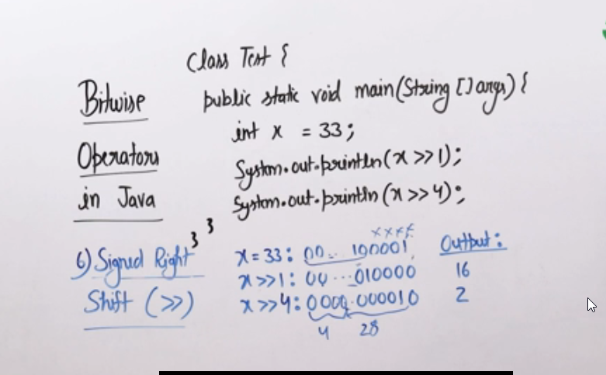

The signed shift operator takes care of the most significant bit(i.e left most bit) and ensures it matches the input.

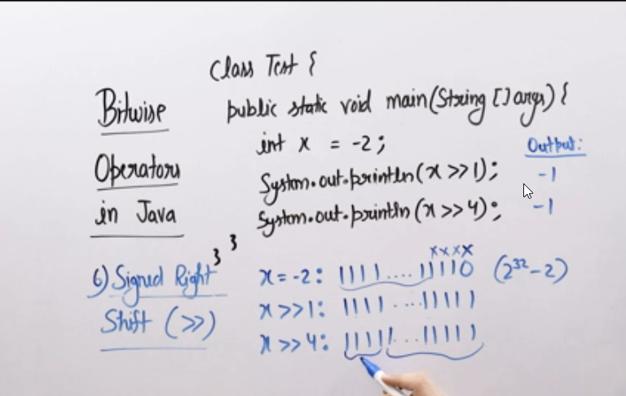

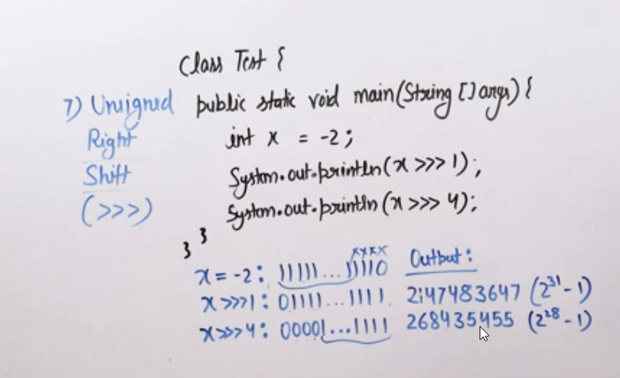

In unsigned right shift , it always fills the leading bits with zero, it doesn’t matter if the number is positive or negative.

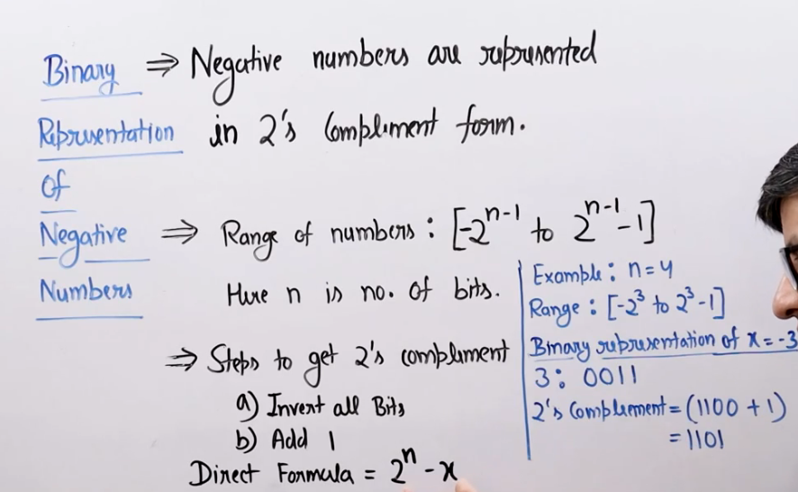

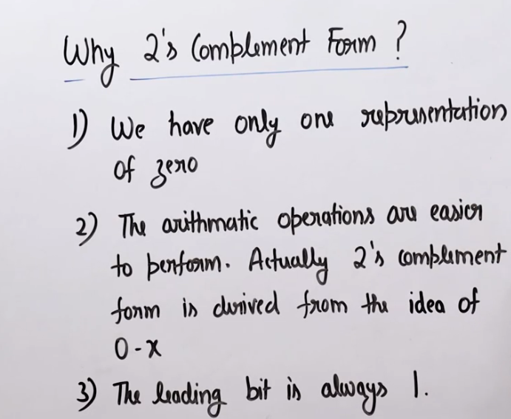

We usually use 2’s complement representation to represent negative numbers in binary form. (Reasons are displayed above)

There are other alternatives as well like

1. 1’s complement - In 1’s complement we usually invert all the bits of the number
2. signed and unsigned bits – In this, the first bit is 1 if number is negative and second bit is 0 if number is positive. One bit is used to represent sign so there is loss of one bit due to this.

**Naïve solution to count number of set bits in a number**

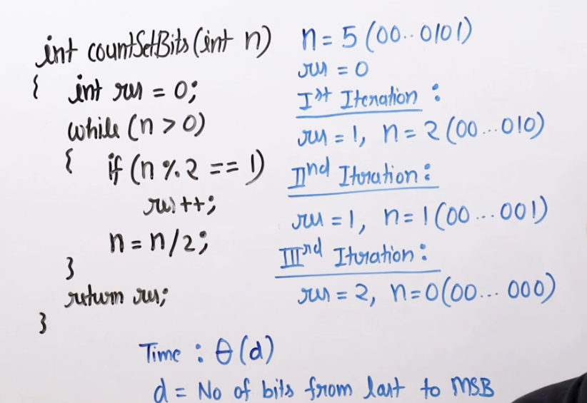

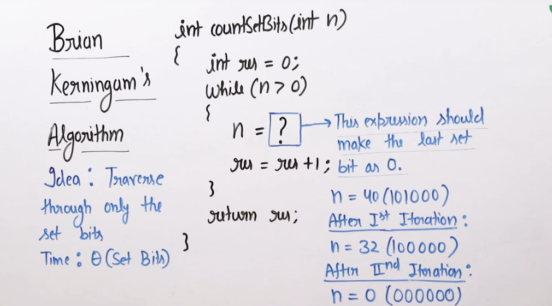

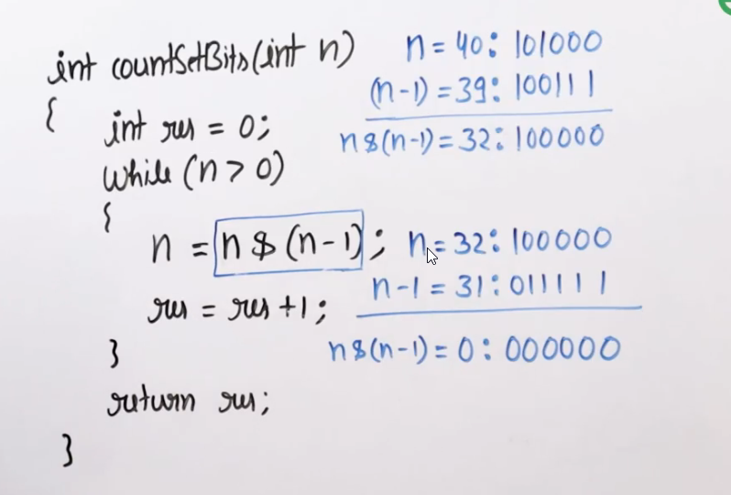

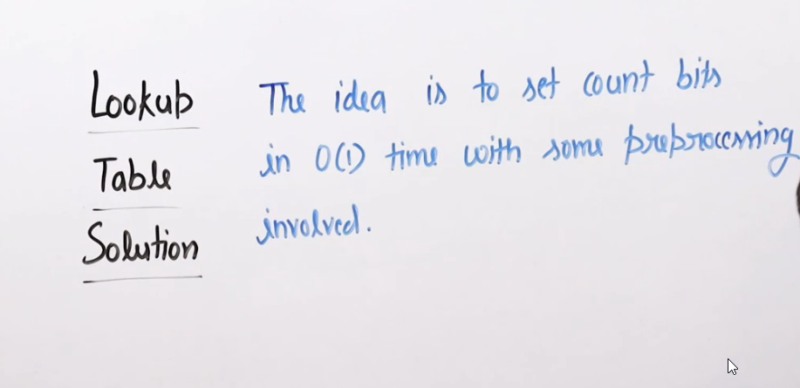

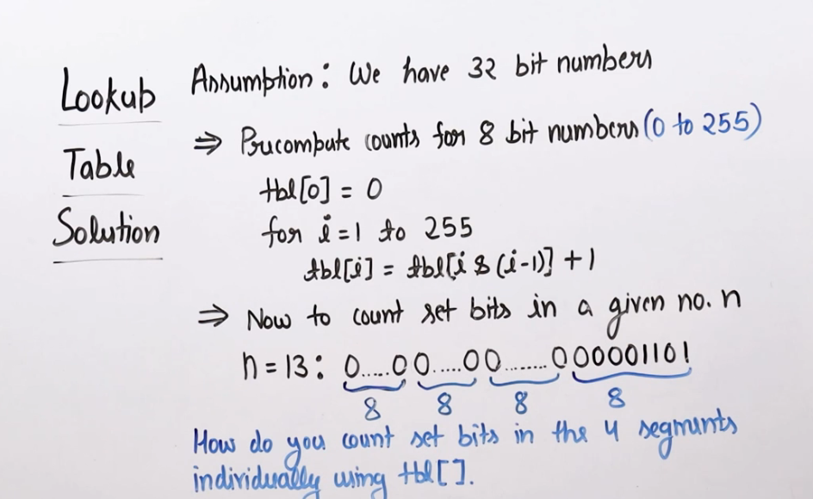

**An efficient solution to check power of 2**

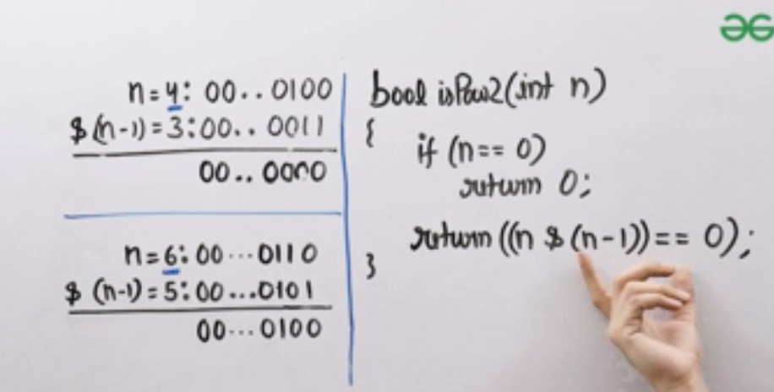

The term n & (n-1) is used to unset rightmost bit of a number and if it has only one set bit , this expression will return 0.

Properties of XOR operator (Gives 1 only when both bits are different)

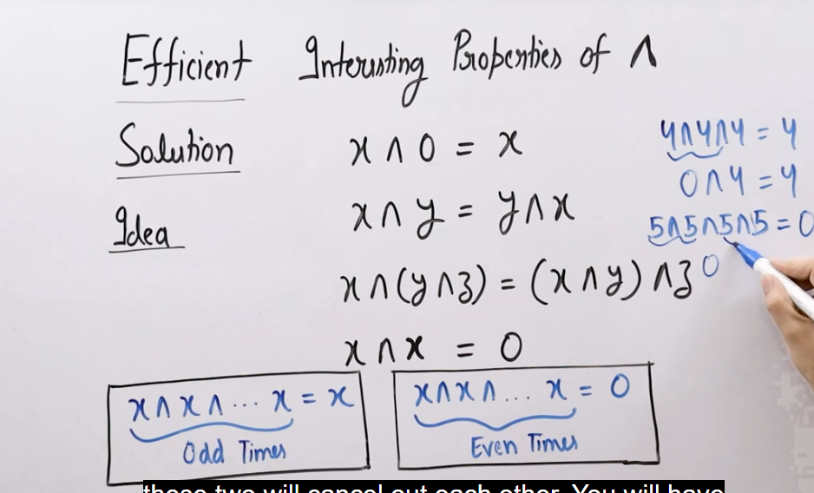

Problem – Find one odd occurring number

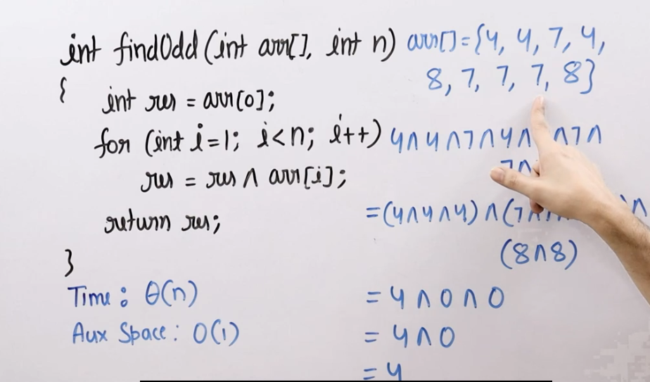

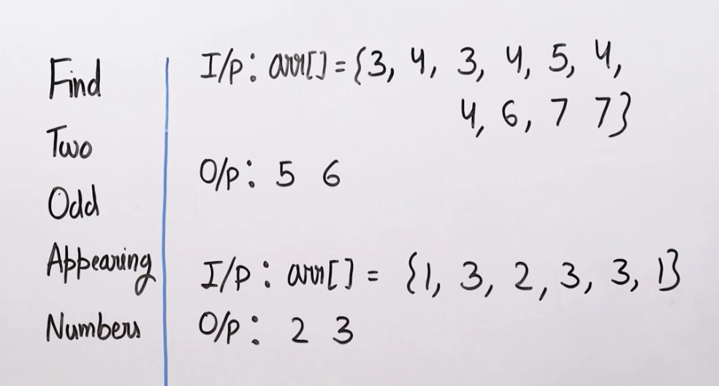

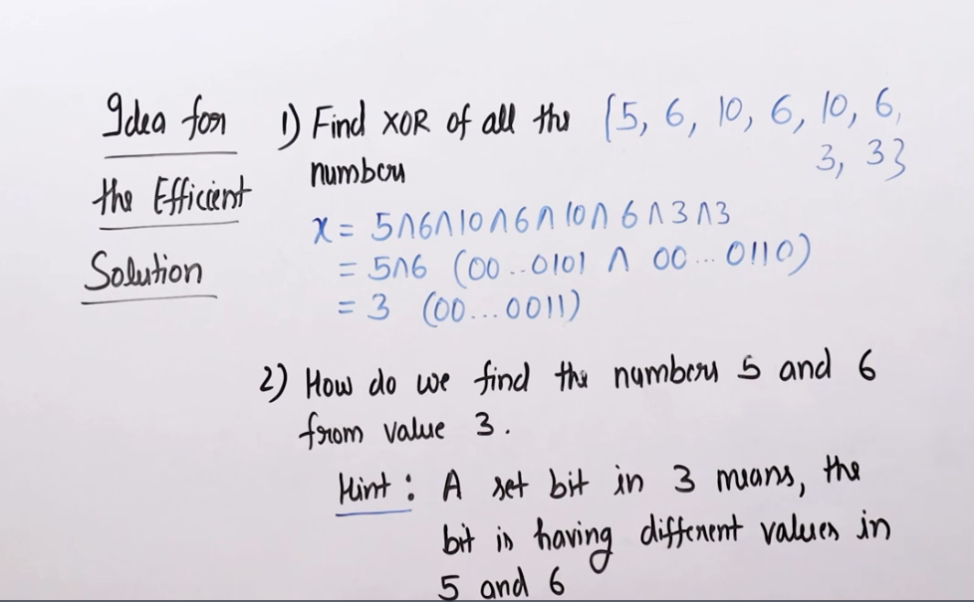

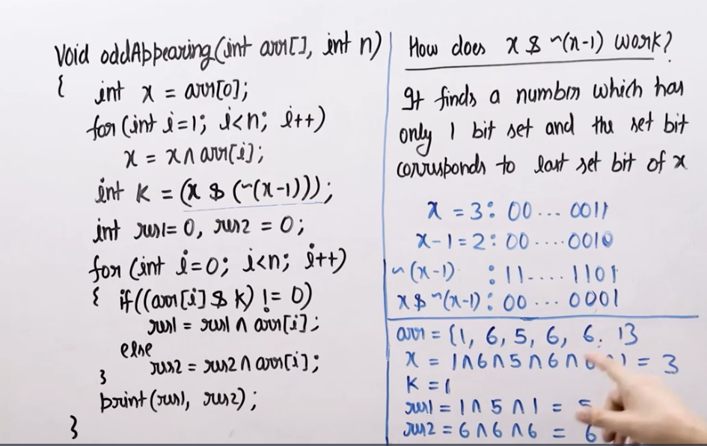

Generating power sets

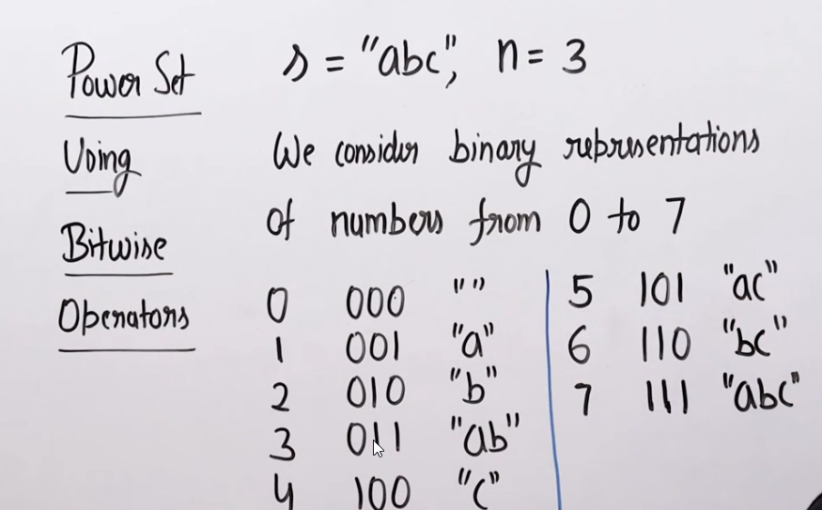

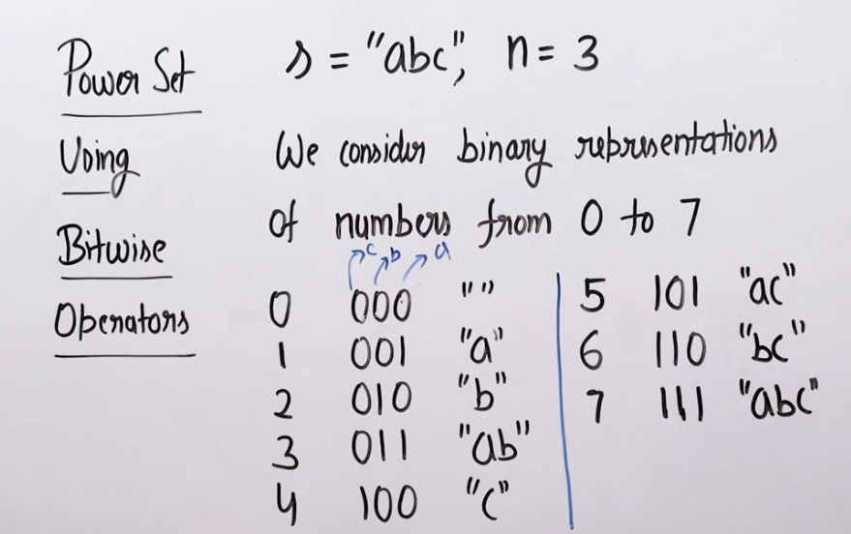

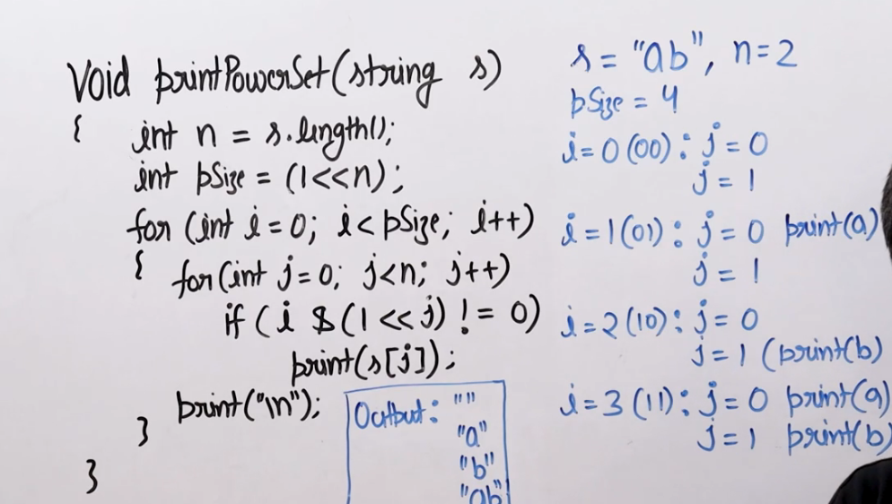

Recursion

Rope cutting problem

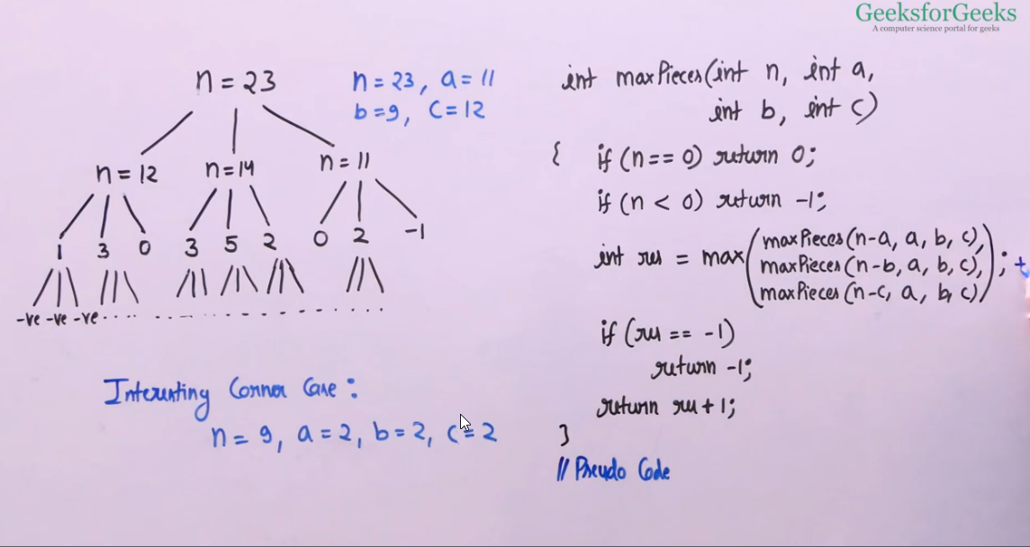

Arrays

Imp question

<https://www.geeksforgeeks.org/given-an-array-arr-find-the-maximum-j-i-such-that-arrj-arri/>

<https://www.geeksforgeeks.org/reduce-a-number-to-1-by-performing-given-operations/>

Array rotation(efficient method)

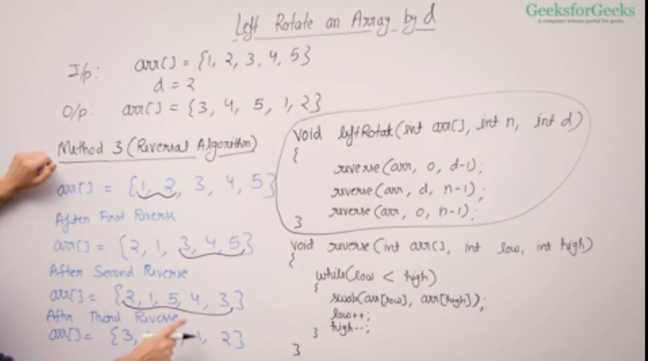

Kandane’s Algorithm

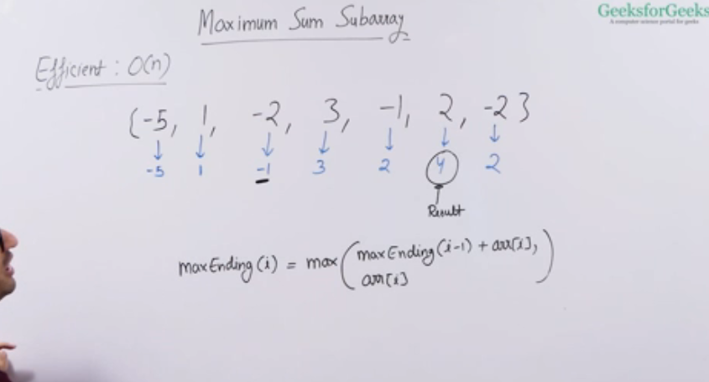

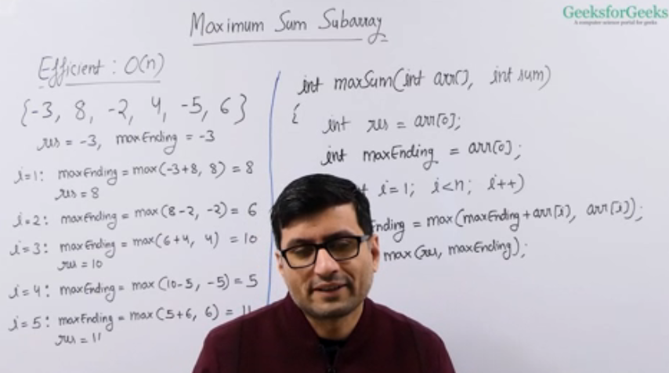

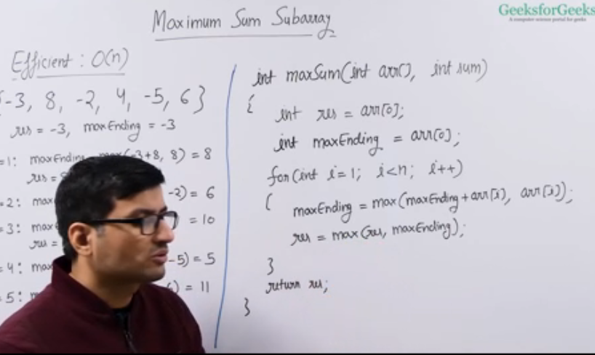

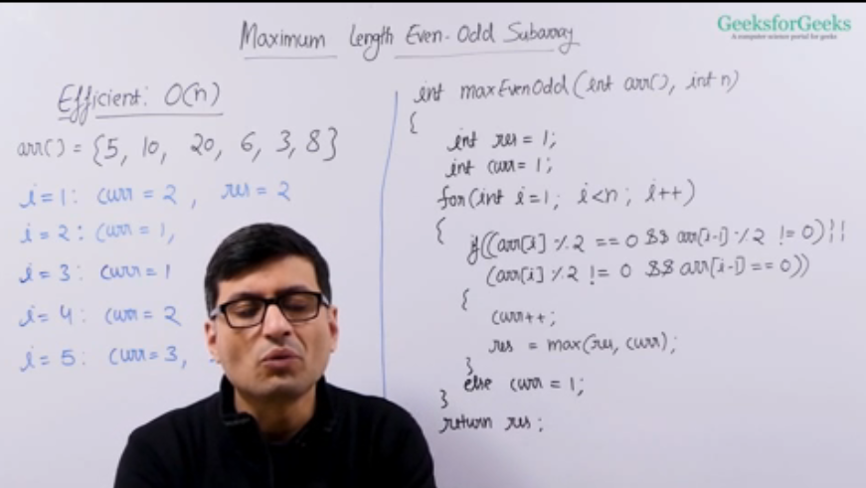

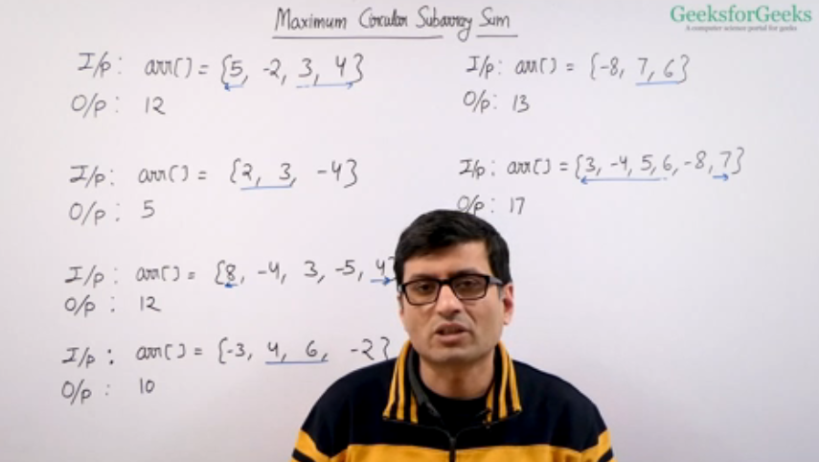

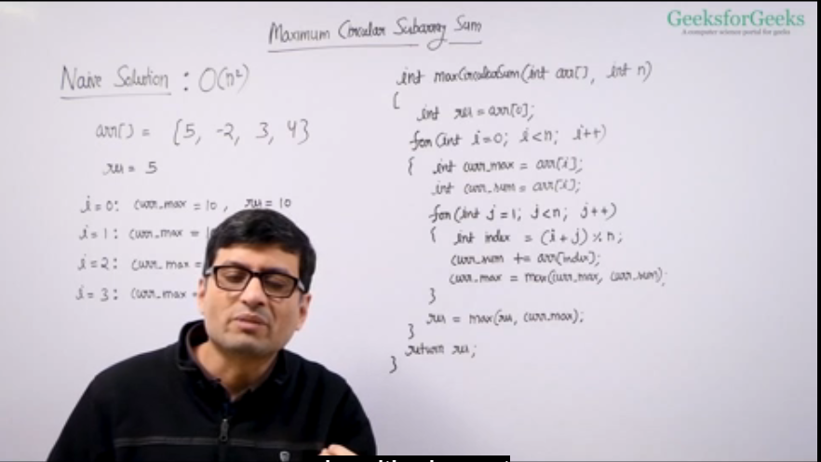

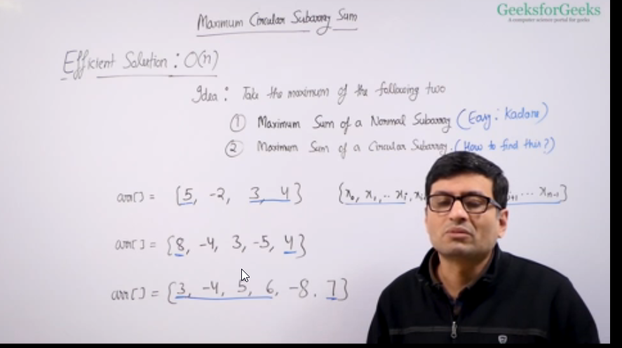

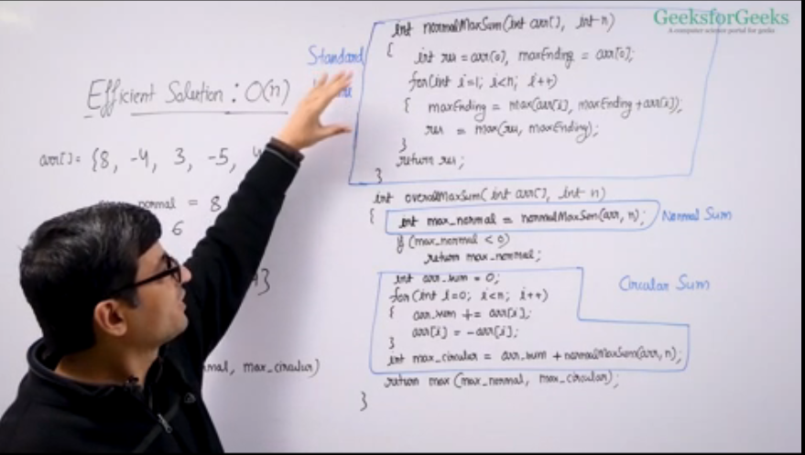

class Solution{

// a: input array

// n: size of array

//Function to find maximum circular subarray sum.

static int circularSubarraySum(int a[], int n) {

//calculate normal maximum using kandane’s algorithm

int max_normal = normalSum(a,n,true);

if(max_normal<0){

return max_normal;

}

int sum=0;

for(int i=0;i<n;i++){

sum+=a[i];

}

//calculate the circular sum of contiguous elements using kandane’s algorithm

//find the minimum sum of contiguous elements and subtract it from total sum to get maximum sum.

int max_circular = sum - normalSum(a,n,false);

return (int)(Math.max(max_normal,max_circular));

}

static int normalSum(int a[], int n,boolean isMax) {

int sum = a[0],maxSum=a[0];

for(int i=1;i<n;i++){

if(isMax){

sum = Math.max(sum+a[i],a[i]);

maxSum = Math.max(sum,maxSum);

}else{

sum = Math.min(sum+a[i],a[i]);

maxSum = Math.min(sum,maxSum);

}

}

return maxSum;

}

<https://www.geeksforgeeks.org/boyer-moore-majority-voting-algorithm/>

<https://www.geeksforgeeks.org/rearrange-given-array-place/>

<https://practice.geeksforgeeks.org/problems/subarray-with-given-sum-1587115621/1>

**Prefix Sum**

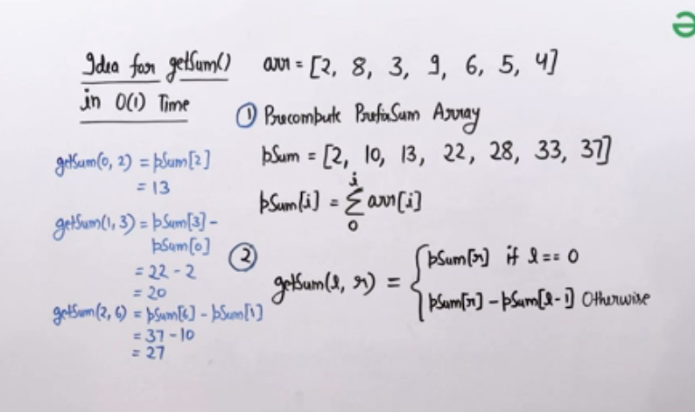

Maximum appearing element in a list/array

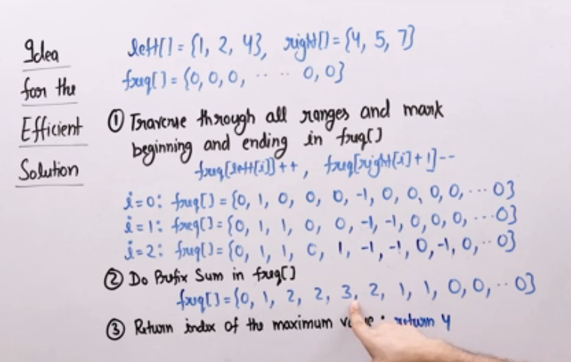

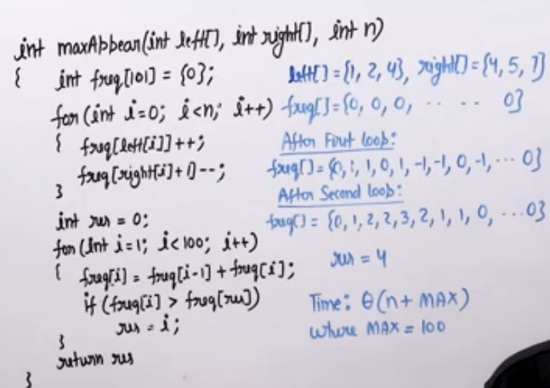

<https://www.geeksforgeeks.org/game-of-chocolates-wythoffs-game/>

Two pointer approach(works on sorted array)

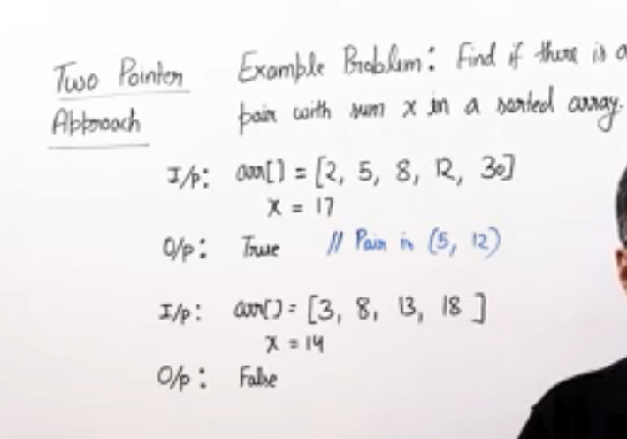

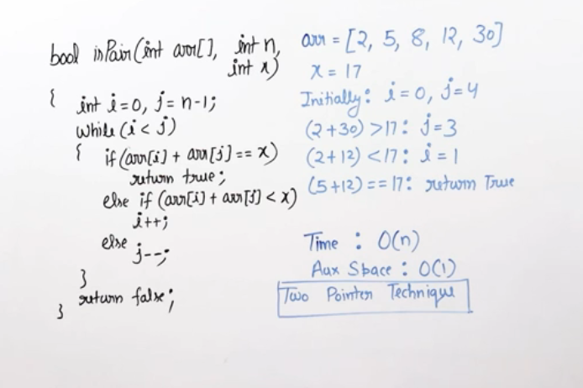

Sorting

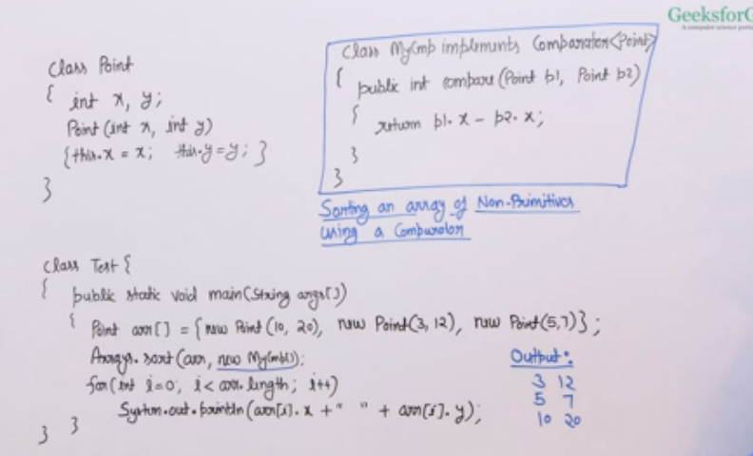

<https://practice.geeksforgeeks.org/batch/dsa-4/track/DSASP-Sorting/problem/union-of-two-sorted-arrays-1587115621>

Count Inversion in the array

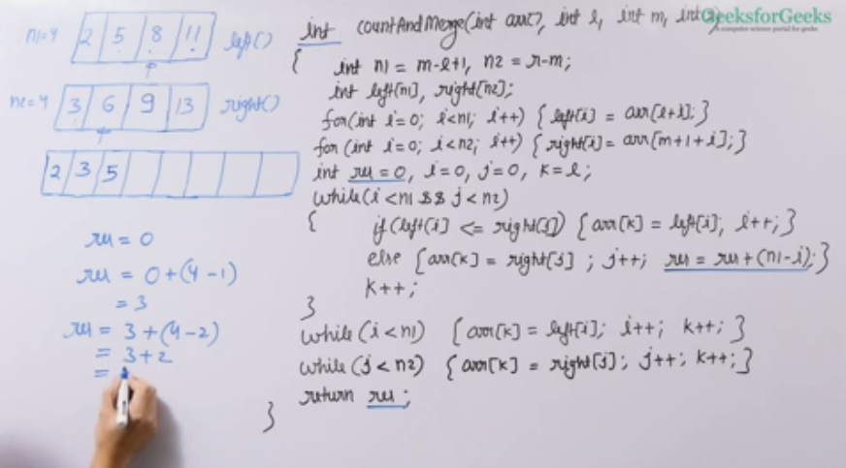

Quick Sort

Lomuto Partition

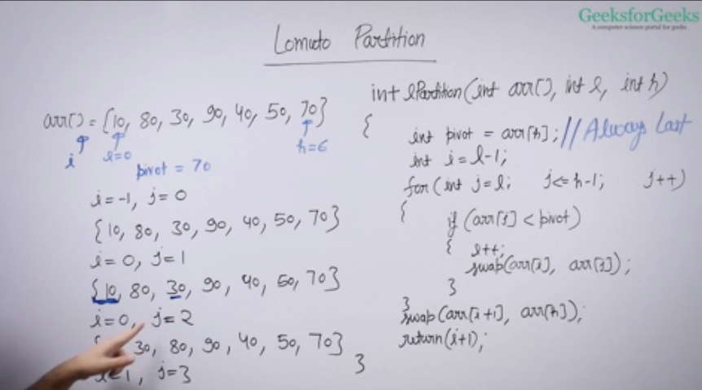

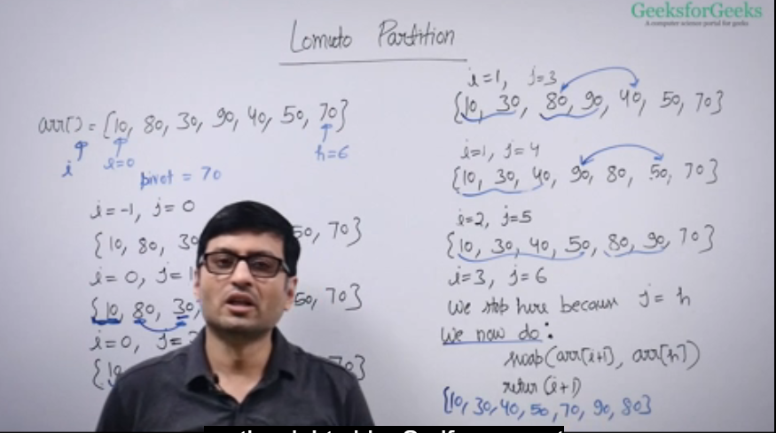

Hoare Partition

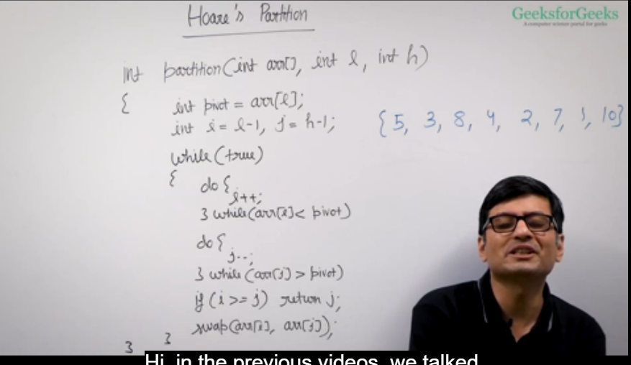

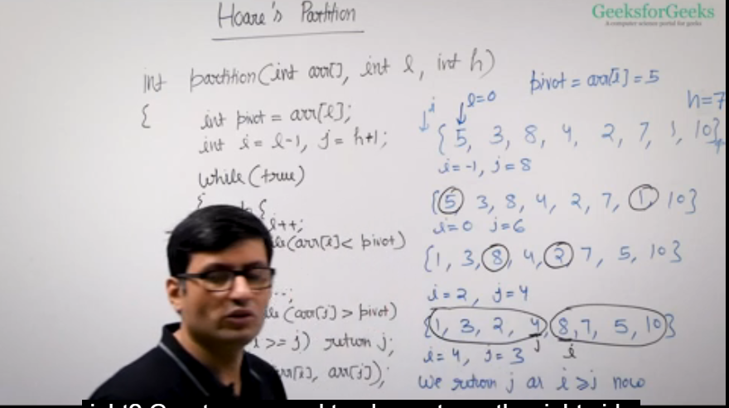

Quick Sort

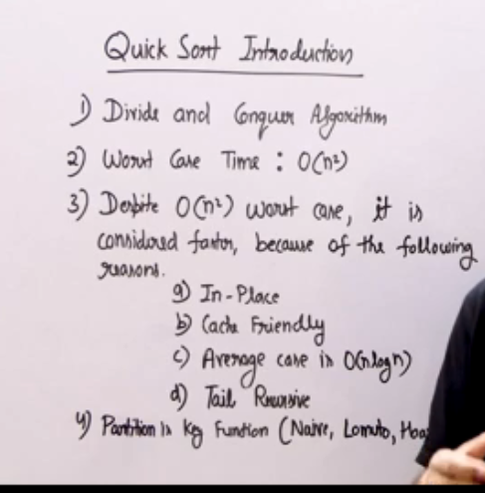

Kth smallest element

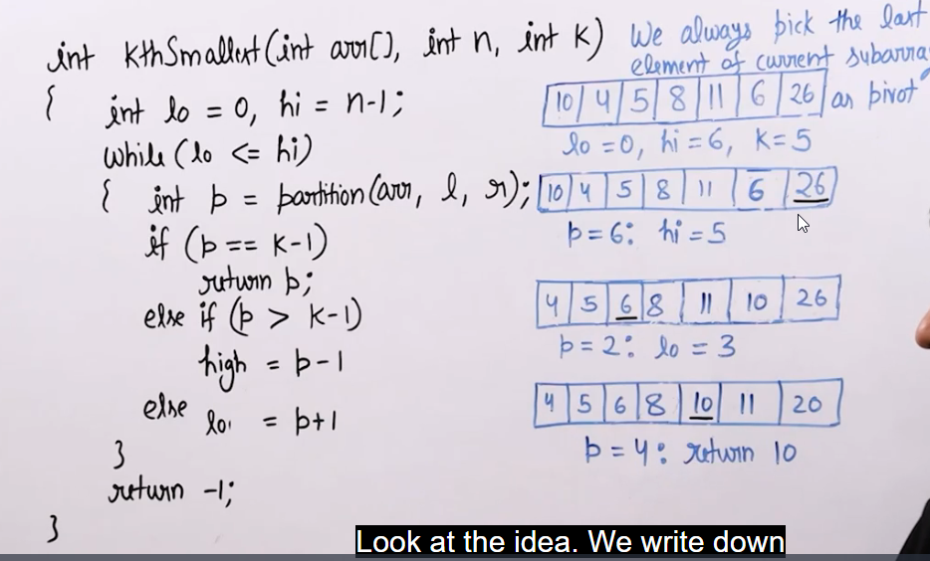

Meeting maximum guests

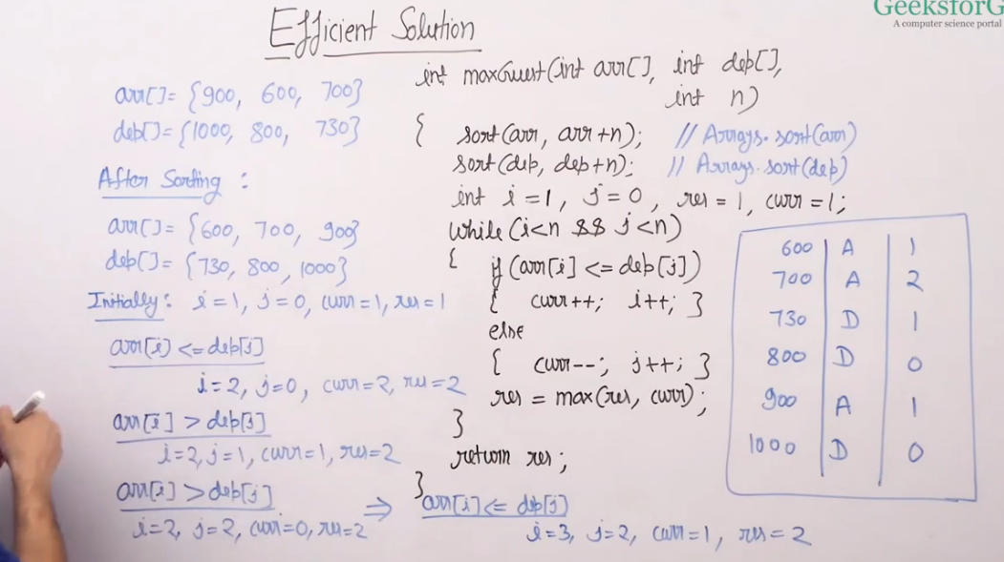

Cycle Sort

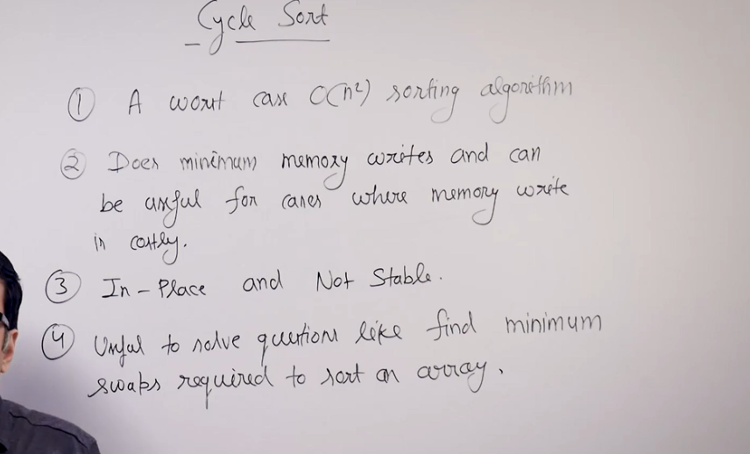

Counting Sort

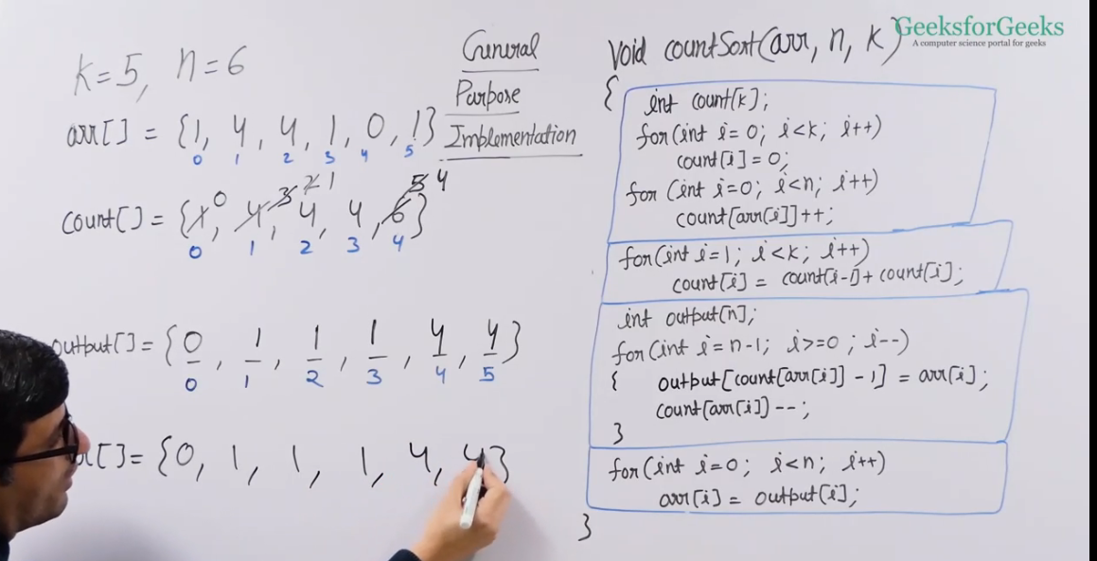

Merge overlapping Intervals

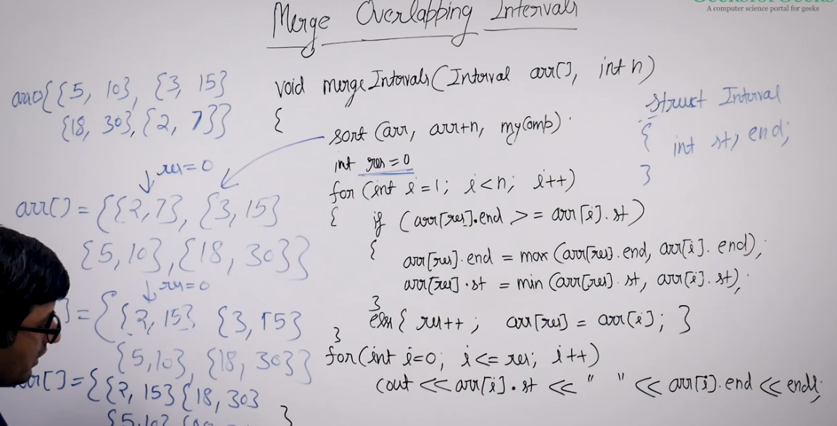

Rotate Matrix by 90 degree

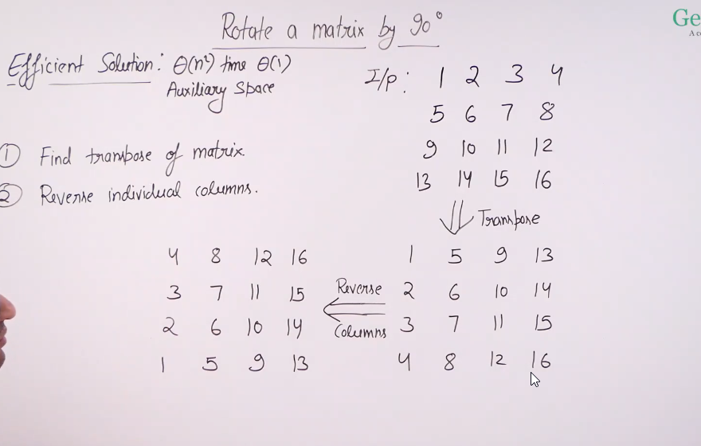

**Spiral Traversal of Matrix**

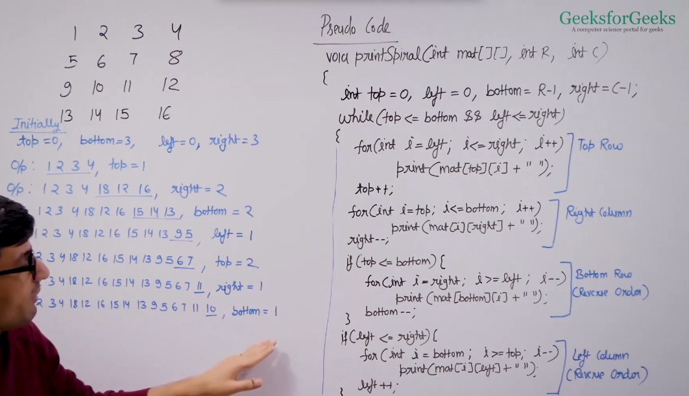

Median of a Row Wise Sorted Matrix

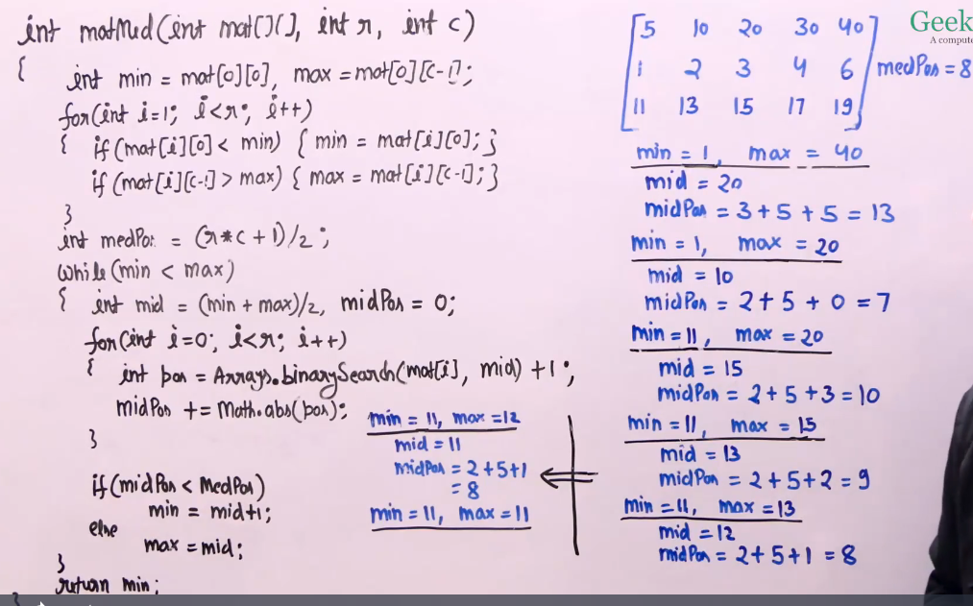

SubArray with given sum(Efficient approach using hashing)

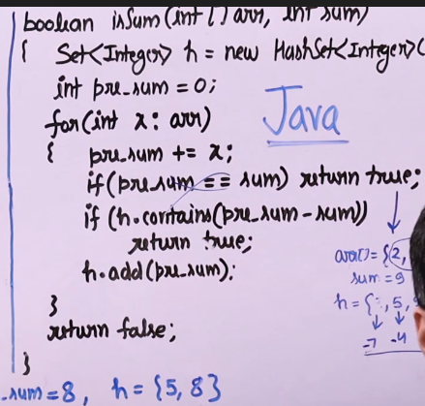

**Zero sum subarrays**

Index                                         { 0,   1,  2,  3,  4,   5,  6,  7}

If the array is                             { 5,  -2,  2,  3,  -3,  1,  2, -2}

so the prefix sum array will be  { 5,   3,  5,  8,   5,  6,  8,  6}

Now there is a zero-sum subarray from index 3 to 4, {-2, 2}. So the prefix sum of index 2 is repeated at index  4. The same thing is happening for sub-array {3,  -3} and {-2,  2,  3,  -3}.

So we can say that if the prefix sum at index l repeats at index r, there is a zero-sum subarray from l+1 to r.

***How to count the sub-arrays.***

Now for a prefix sum [ prefix_sum[i] ],

if the count is 2 then there is 1 zero-sum subarray

if the count is 3 then there is 3 zero-sum subarray

if the count is 4 then there is 6 zero-sum subarray

if the count is n then there is nC2 = (n*(n-1))/2 zero-sum subarray

for the given array

count of presum value 5 is 3, so the ans is (3*2)/2=3,

count of presum value 8 is 2, so the ans is 3+(2*1)/2 = 3+1 = 4

count of presum value 6 is 2, so the ans is 4+(2*1)/2 = 4+1 = 5

Now if the array is                      { 0  0  1}

so the prefix sum array will be { 0  0  1}

count of 0 is 2, so the ans is (2*1)/2 = 1

This is wrong, we are considering the subarray {0, 0} only.

We have to consider {0}, {0} subarrays also.

To handle this case, if the value of presum is 0, we have to increase the answer.

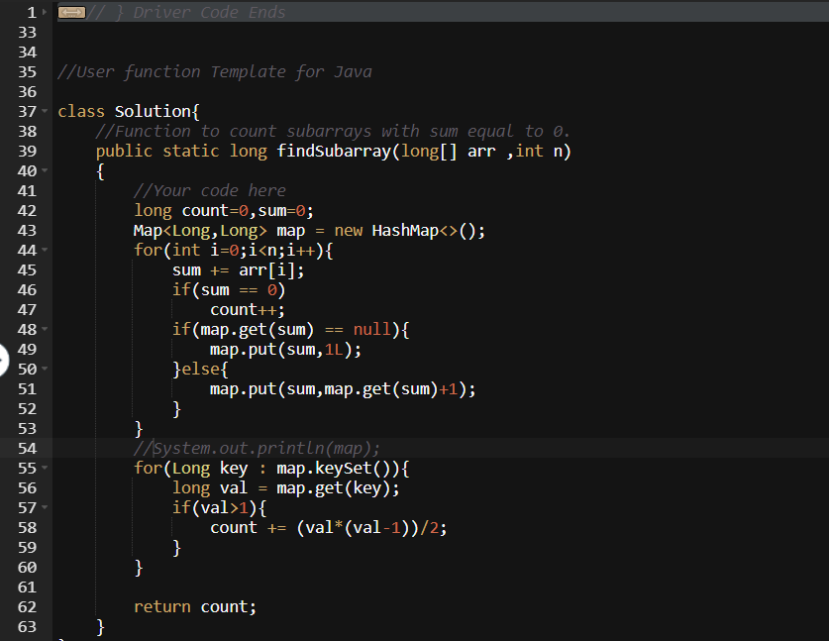

**Longest subarray with given sum**

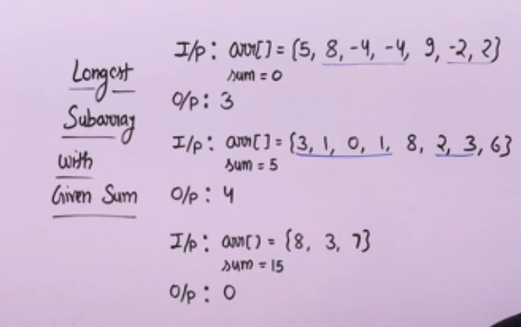

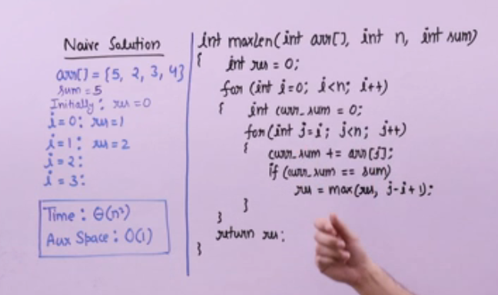

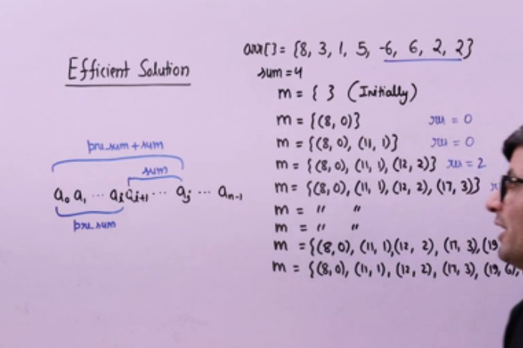

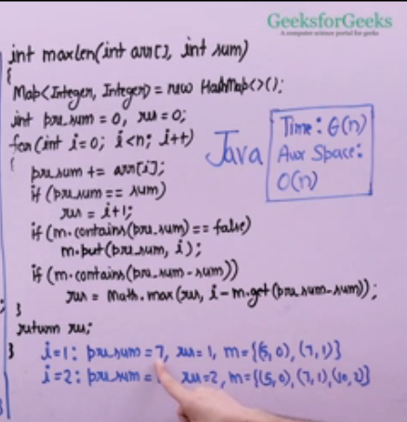

**Strings**

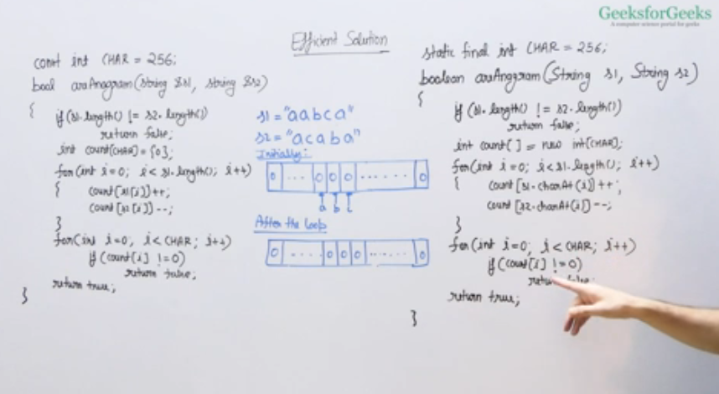

Naïve Pattern Searching algorithm (for pattern with distinct characters)

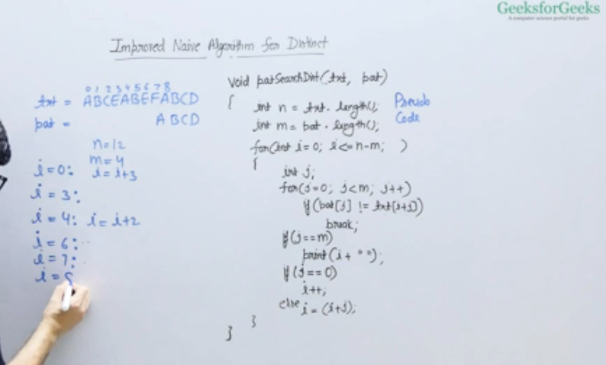

Rabin Karp pattern algorithm

<https://www.geeksforgeeks.org/batch/dsa-4/track/DSASP-Strings/problem/rabin-karp-pattern-searching>

Longest Substring with Distinct Characters

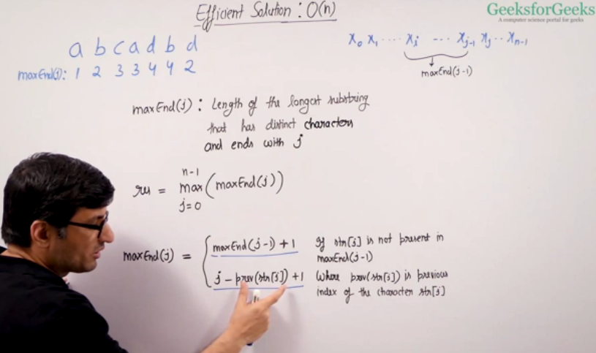

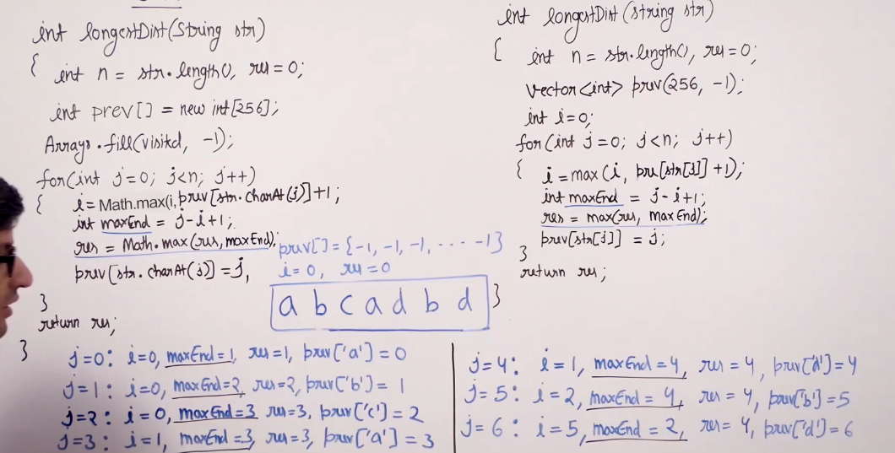

Lexiographic rank of a string

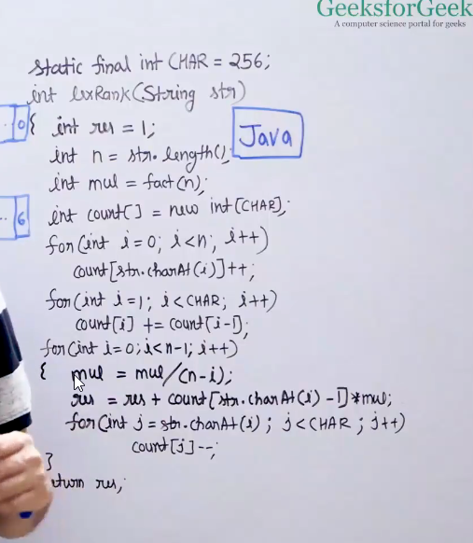

<https://www.geeksforgeeks.org/lexicographic-rank-of-a-string/>

Linked List

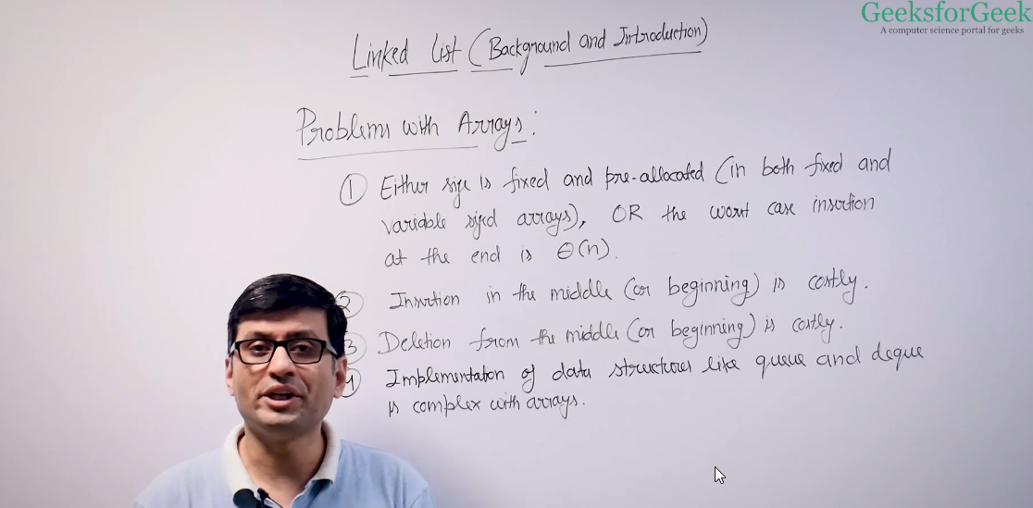

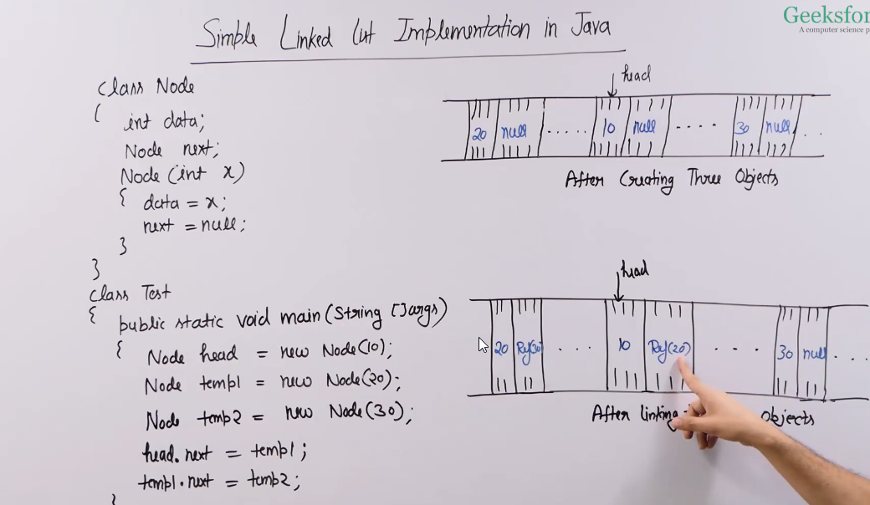

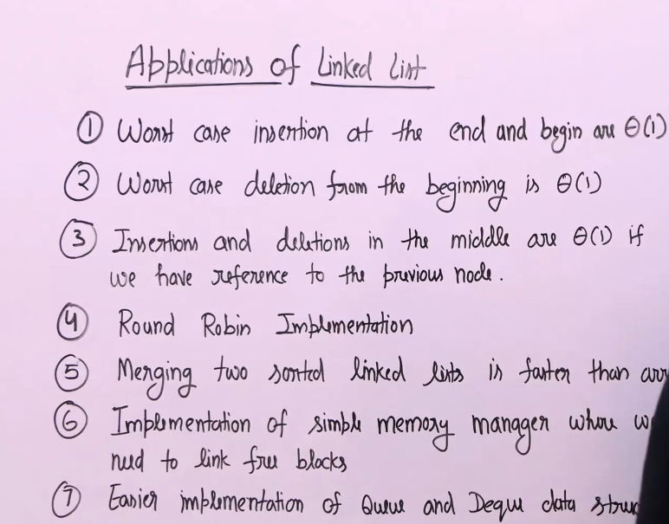

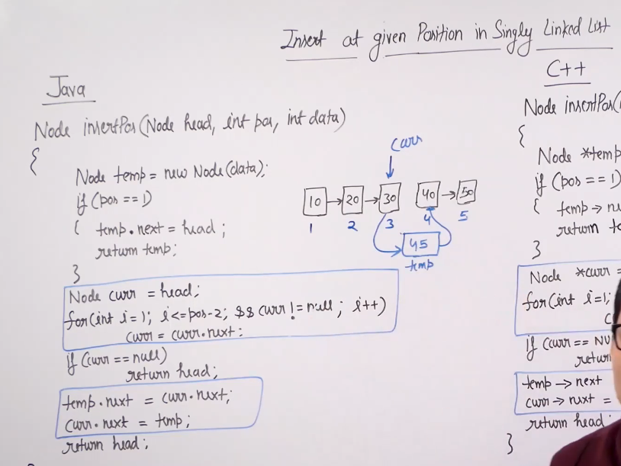

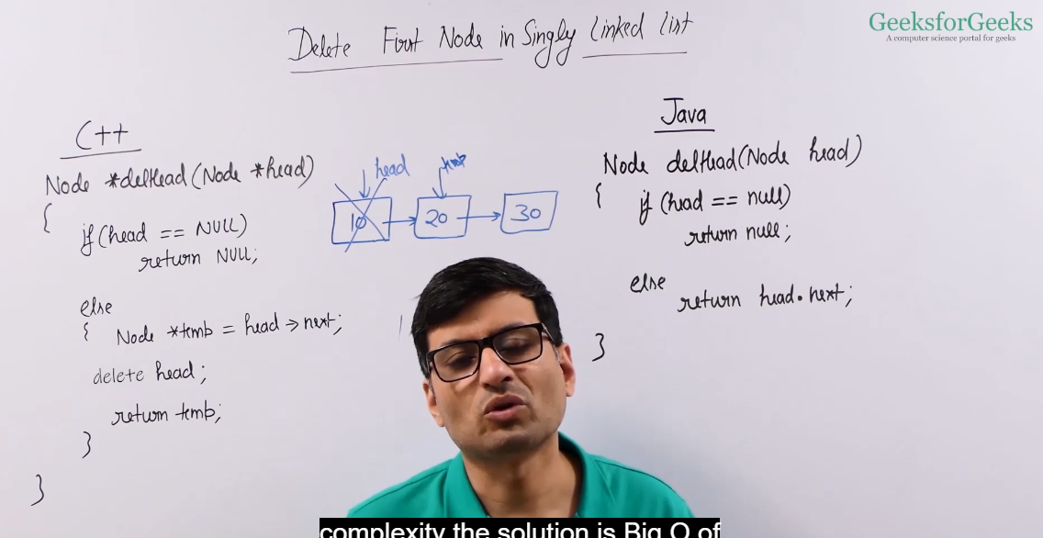

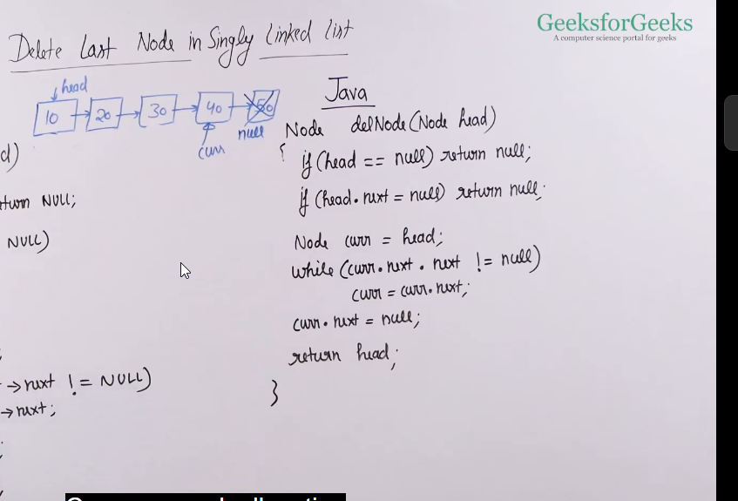

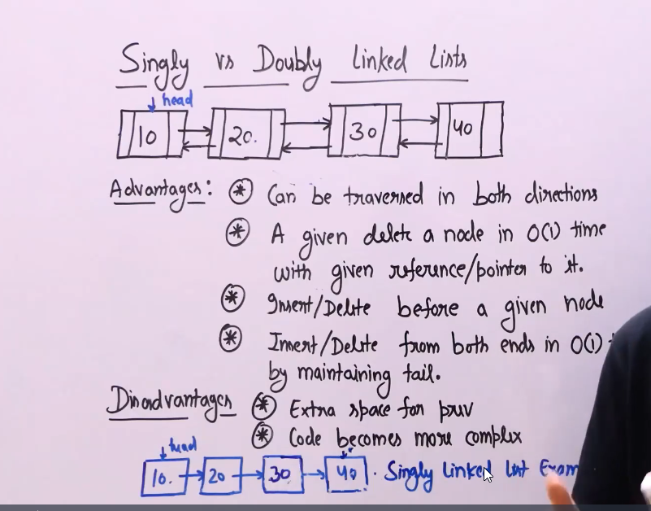

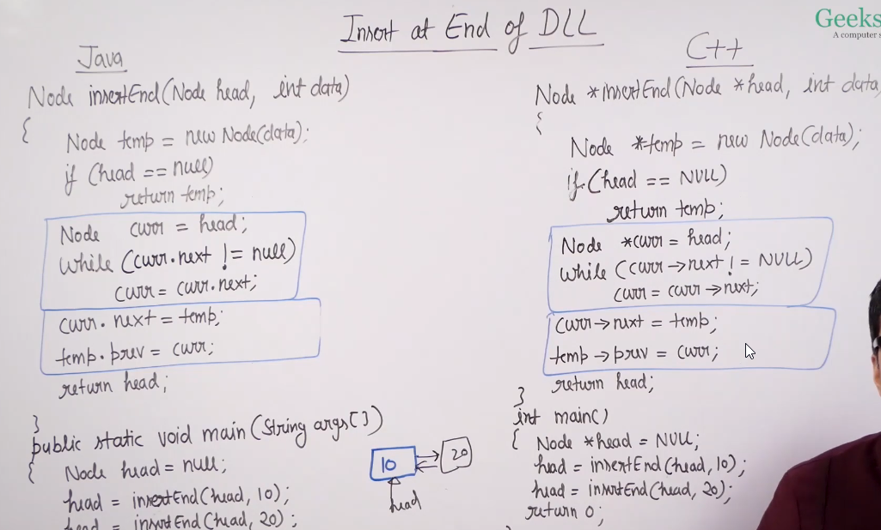

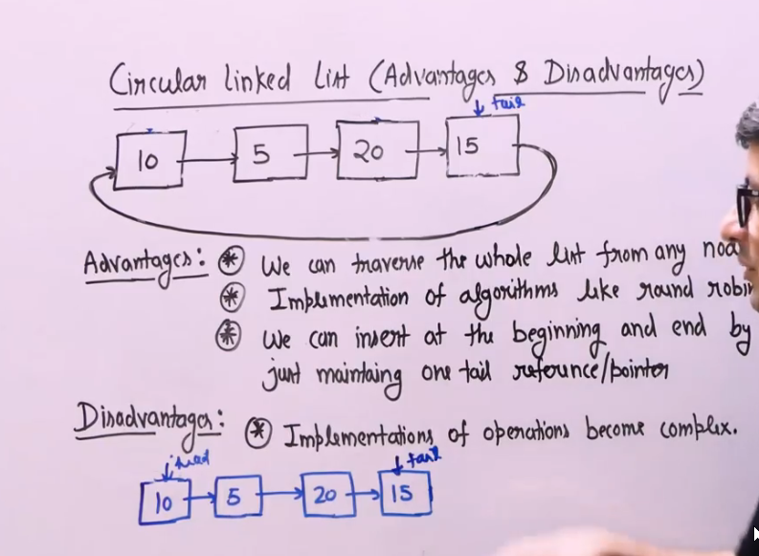

Imp questions

<https://www.geeksforgeeks.org/swap-kth-node-from-beginning-with-kth-node-from-end-in-a-linked-list/>

Nth node from end of linked list (single traversal method)

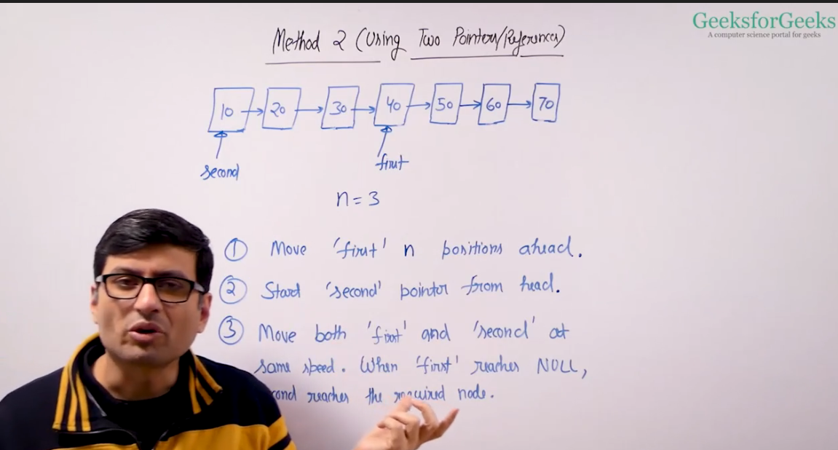

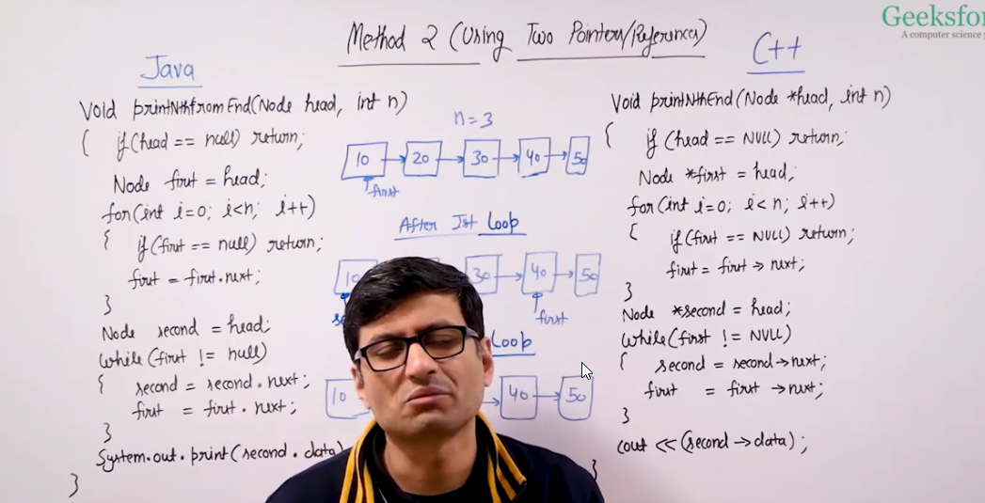

Reverse a linked list (efficient solution)

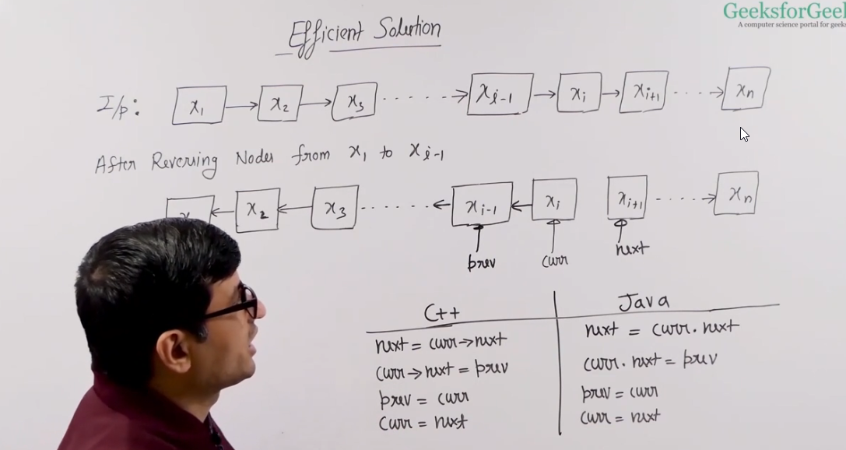

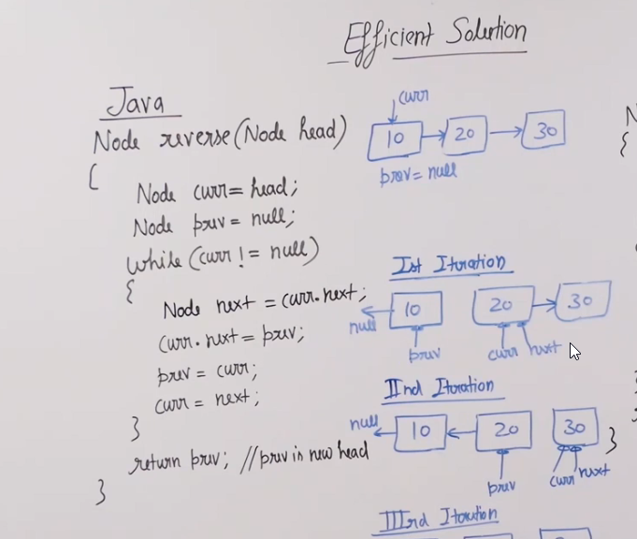

Remove data from sorted linkedlist

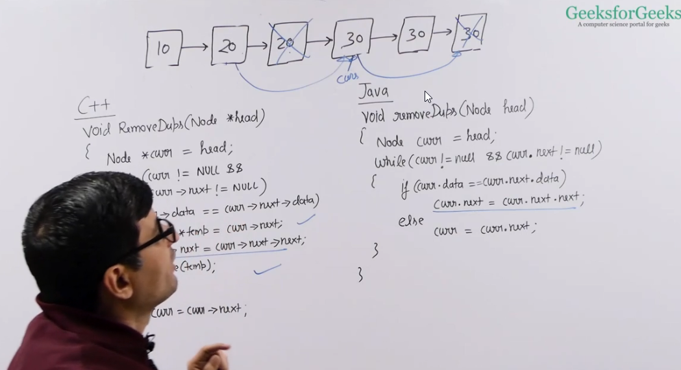

Detect and remove loop in a linkedlist

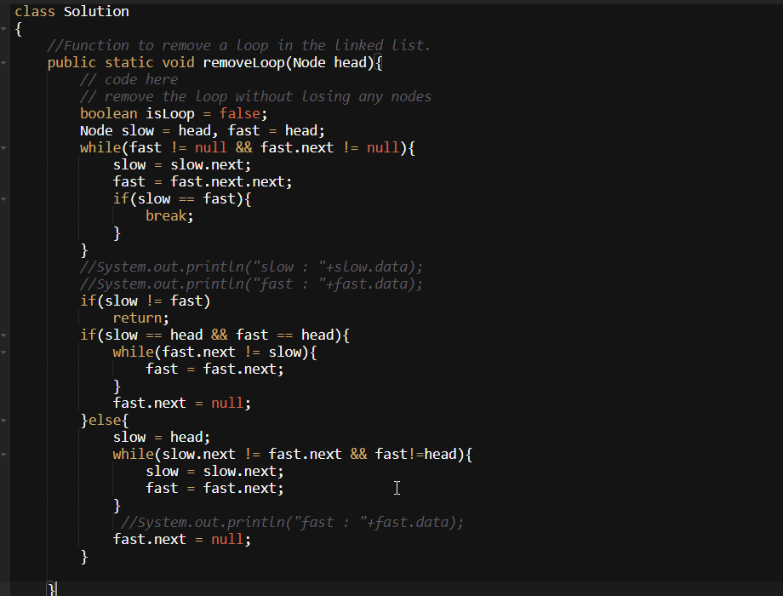

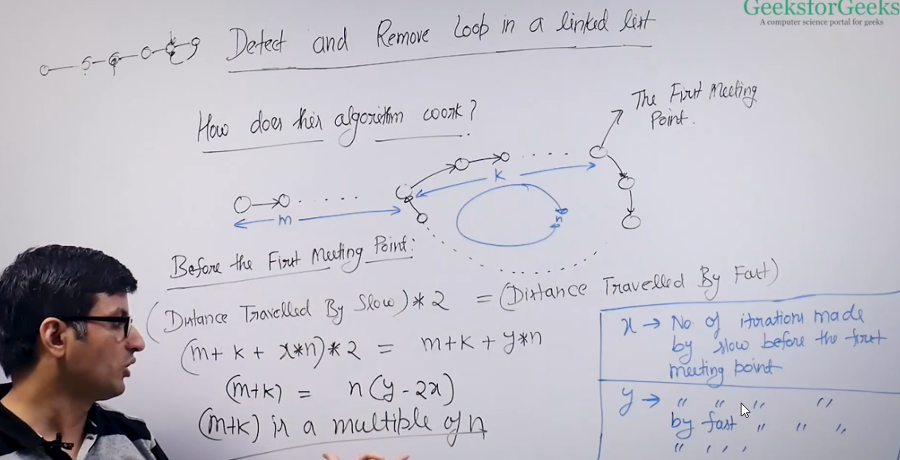

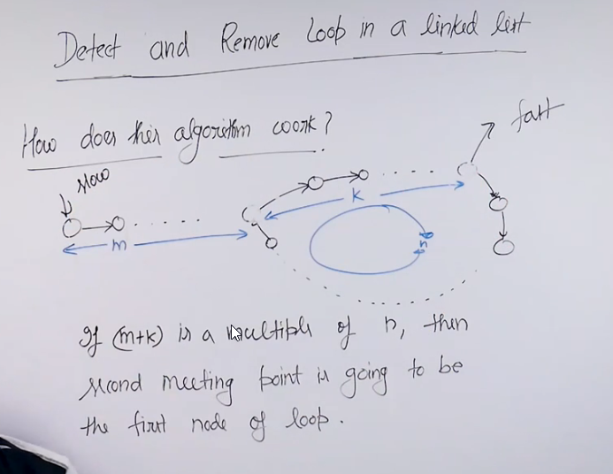

In Floyd cycle detection algorithm, the slow and fast meets at some points in the loop it is not fixed where it will meet.

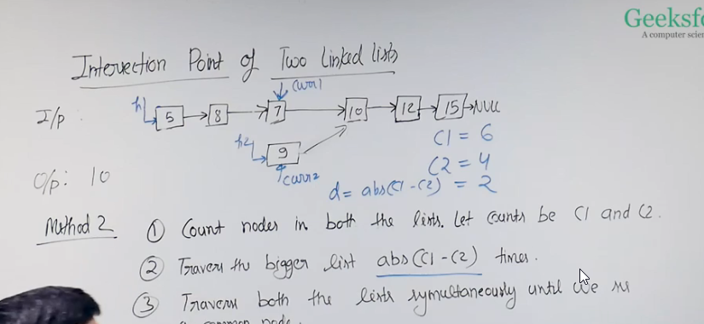

Clone a linked list with Random Pointer in Java

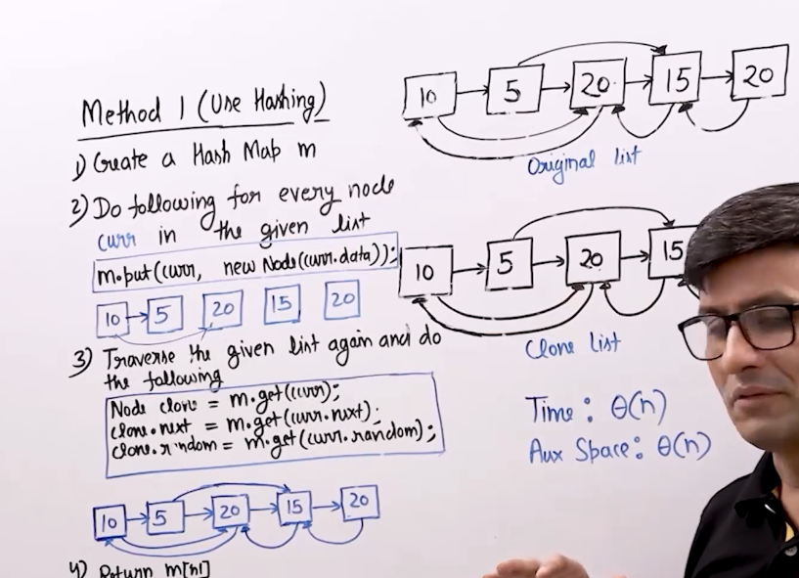

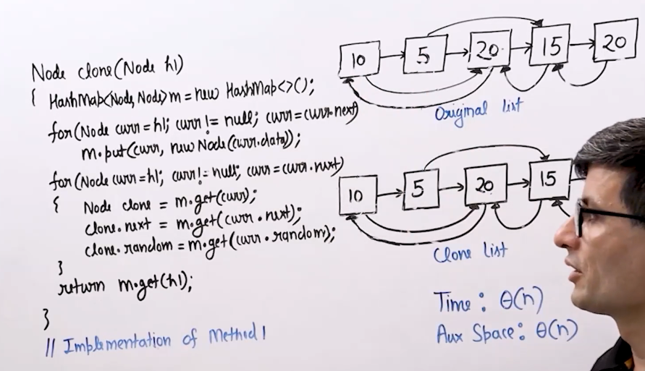

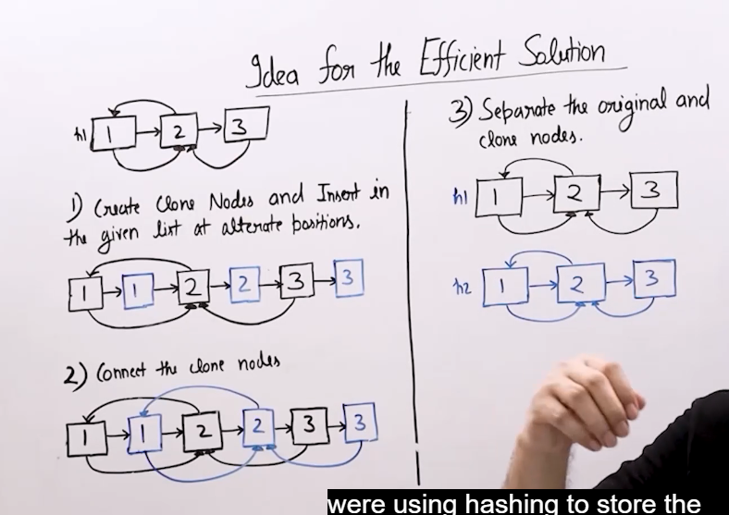

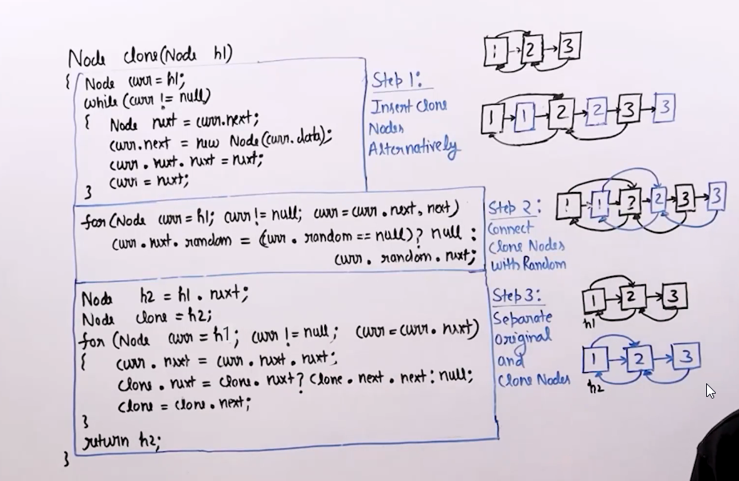

Merge two sorted linkedlist

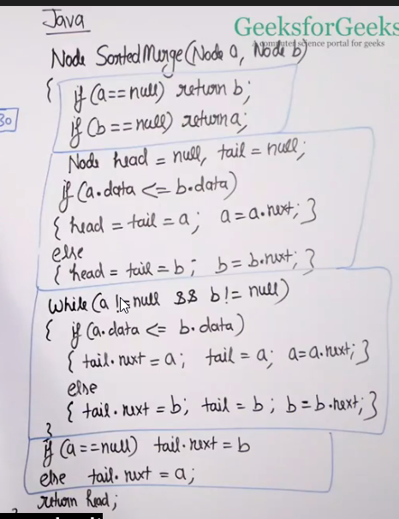

Stack

Stock span problem(Important)

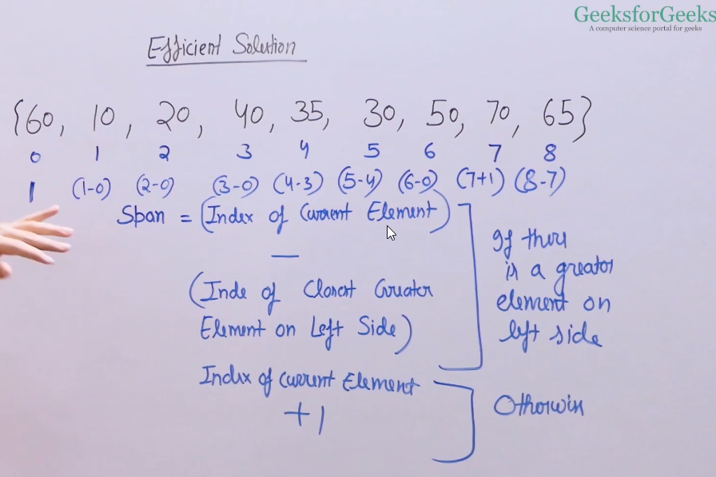

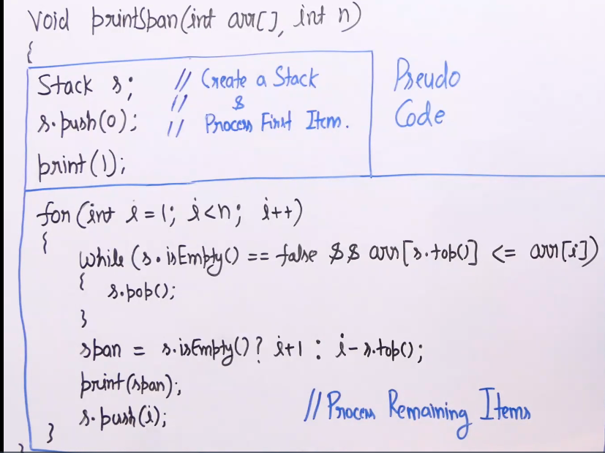

Largest Rectangular area in a histogram

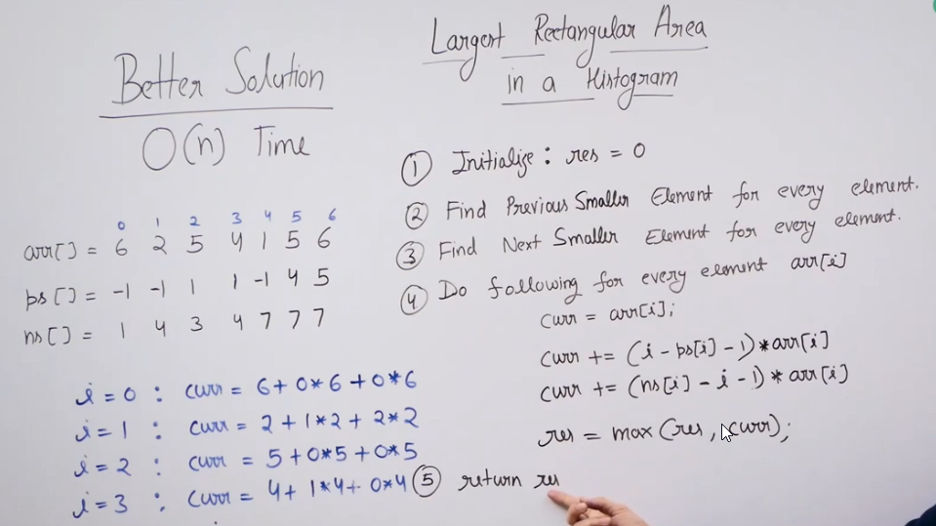

Infix, Prefix,postfix

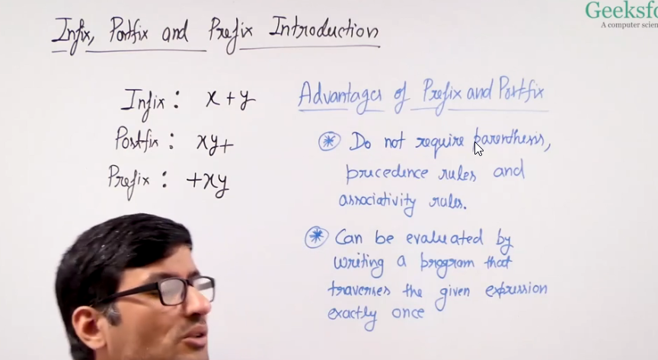

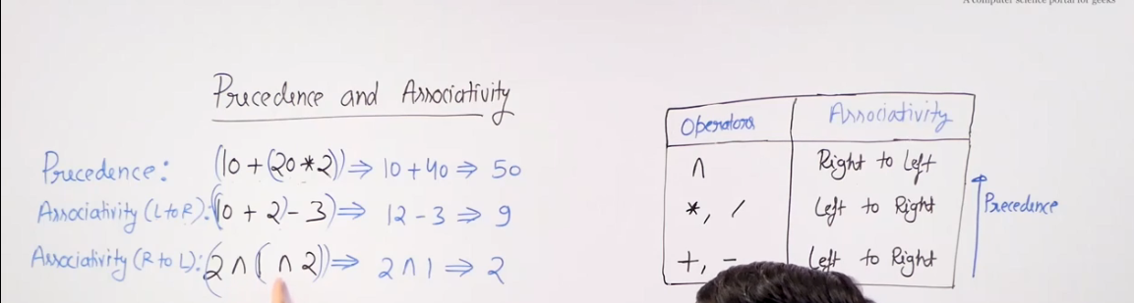

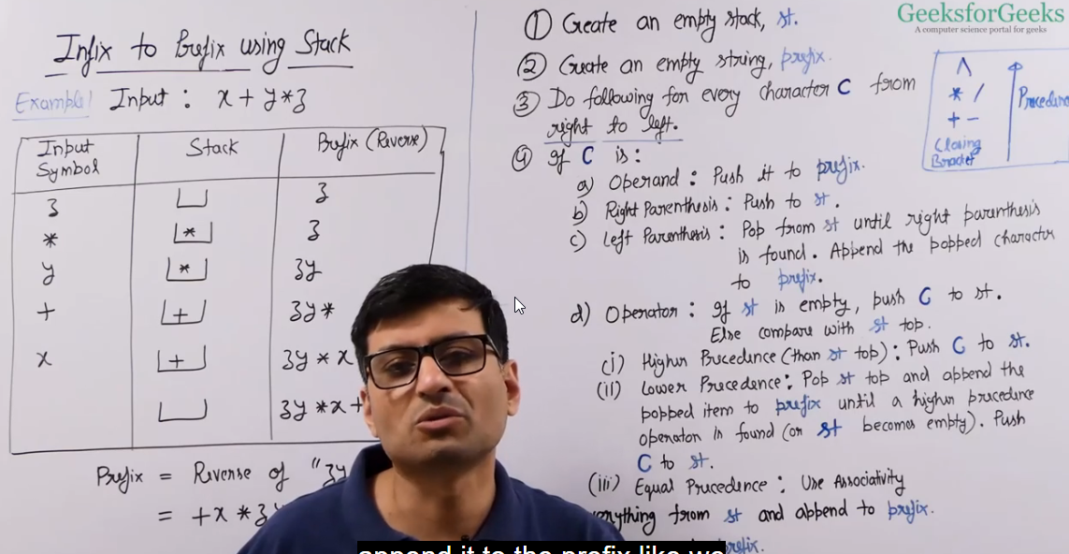

Find largest area in a histogram

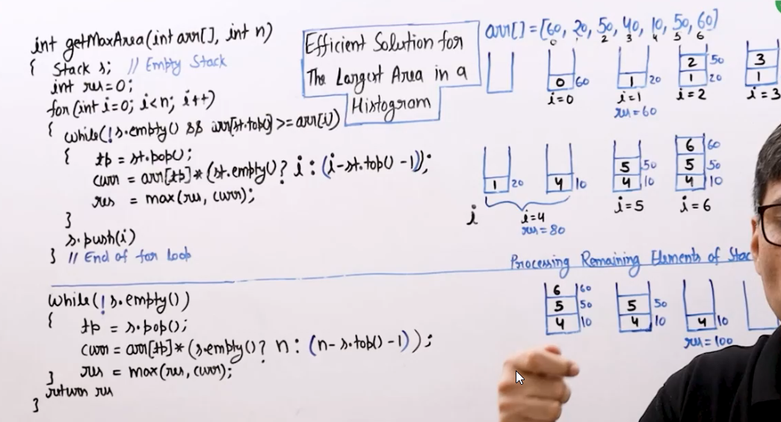

Generate number with given digits

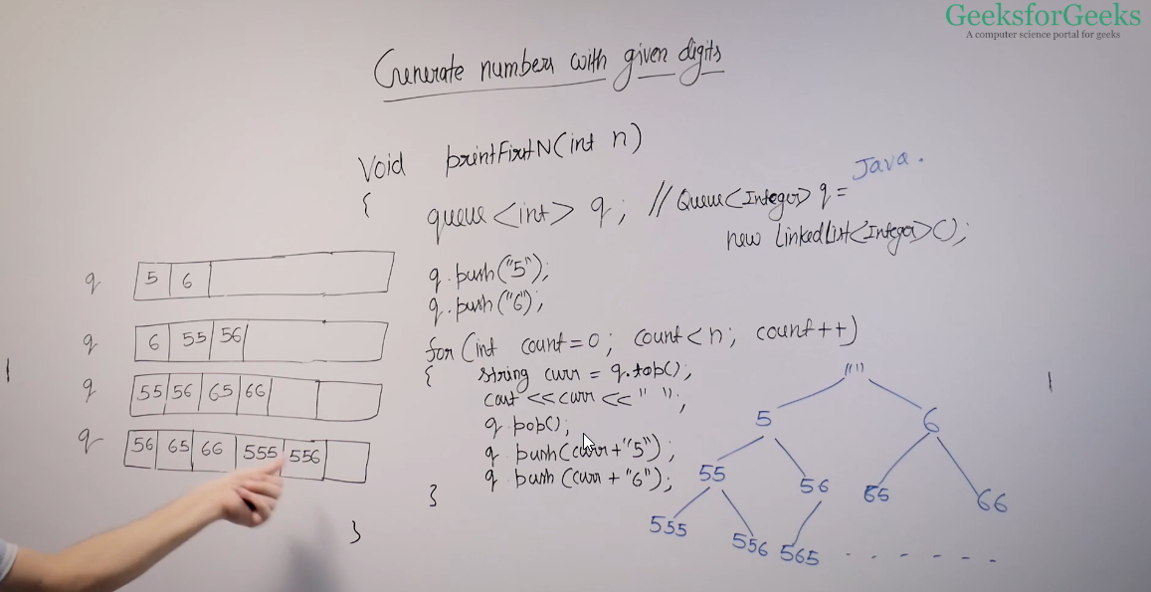

Dequeue (Array Implementation)

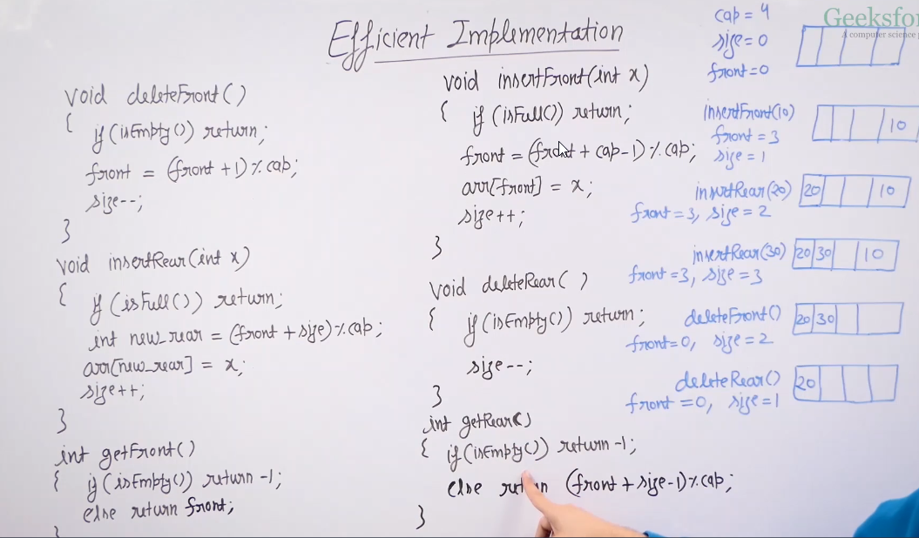

Functions in ArrayDeque class

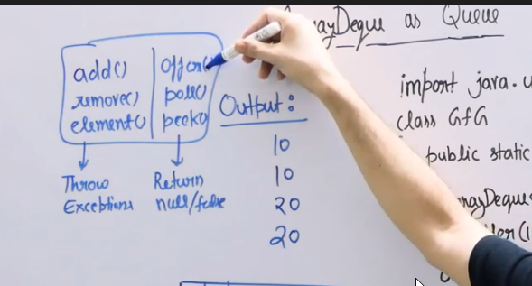

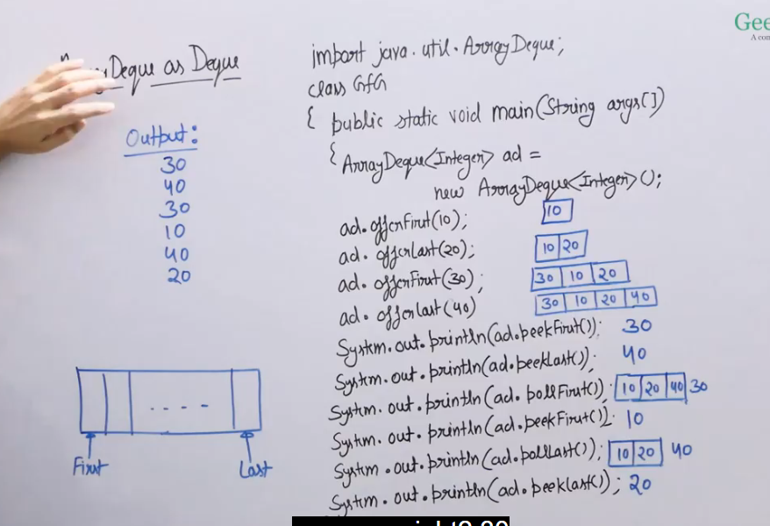

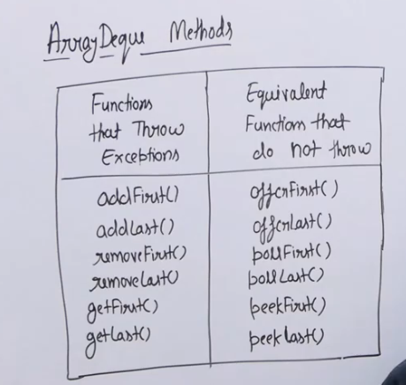

Tree

Important question - <https://www.geeksforgeeks.org/batch/dsa-4/track/DSASP-Tree/problem/binary-tree-to-dll>

Convert binary tree from inorder and preorder traversal

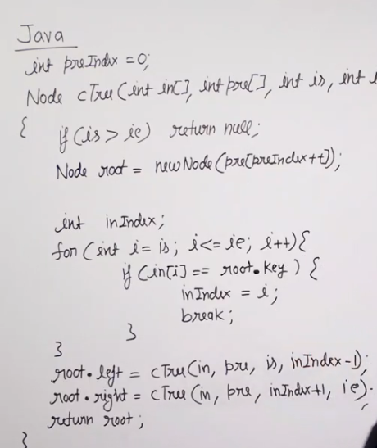

Important problem

Create binary tree from inorder and postorder traversal

<https://www.geeksforgeeks.org/batch/dsa-4/track/DSASP-Tree/problem/tree-from-postorder-and-inorder>

Diameter of a binary tree

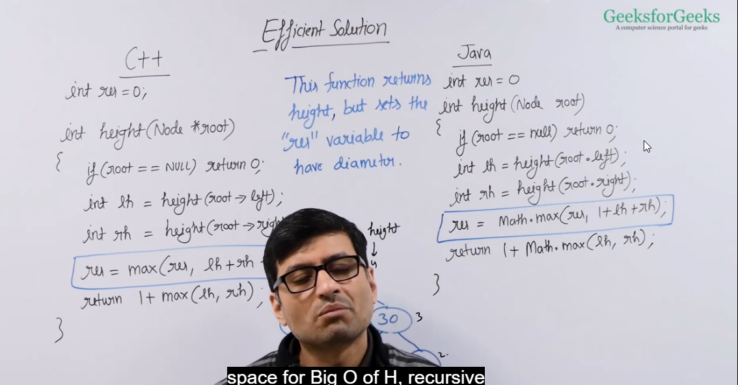

Heap

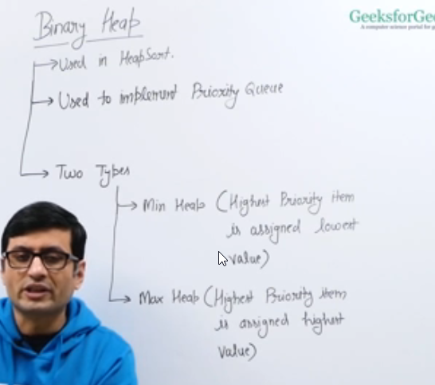

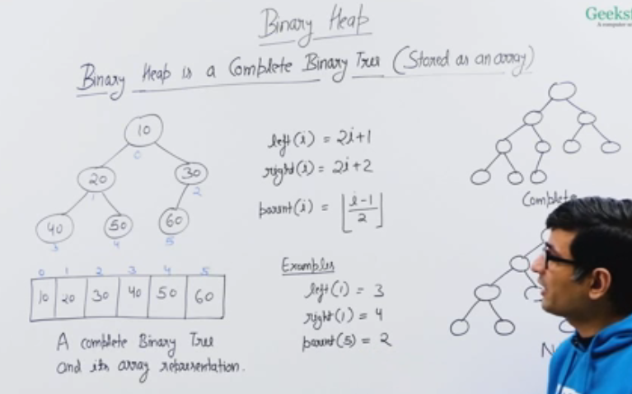

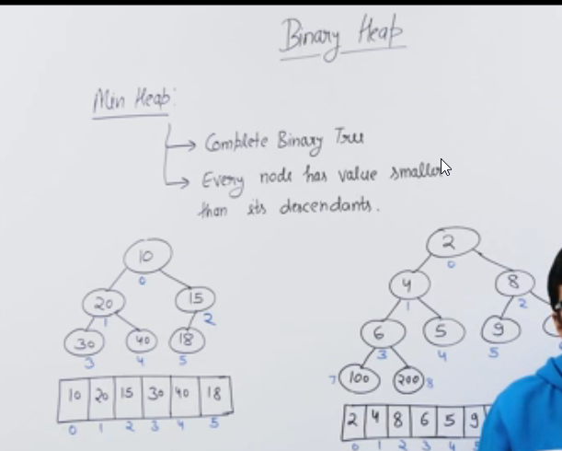

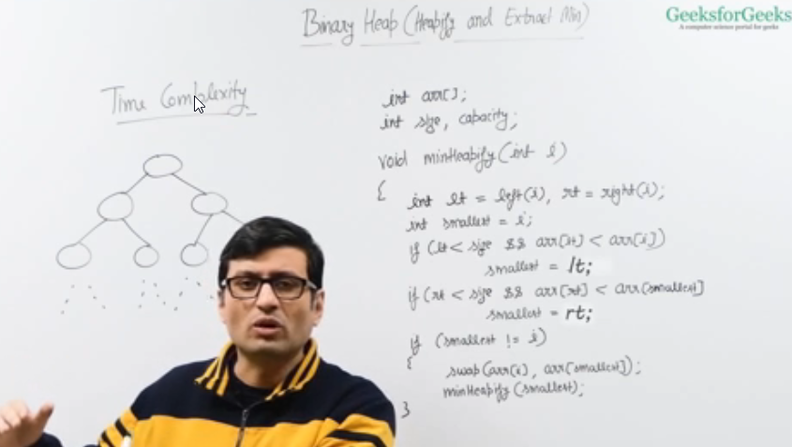

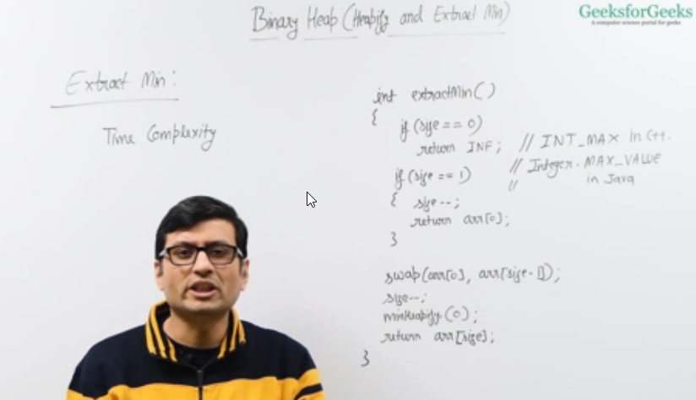

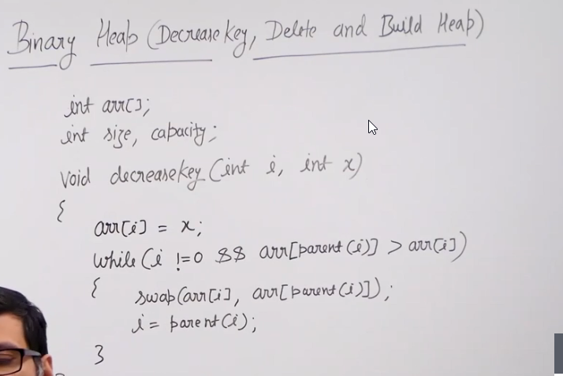

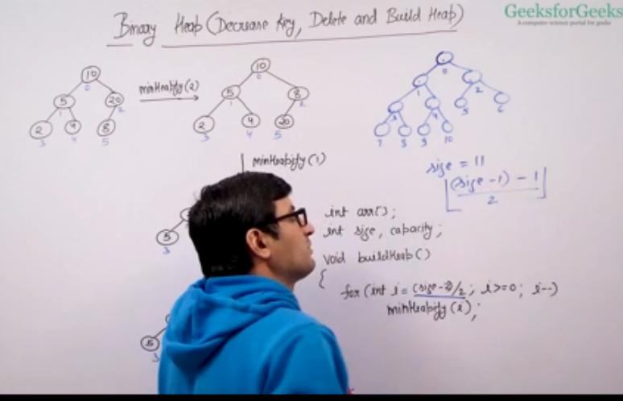

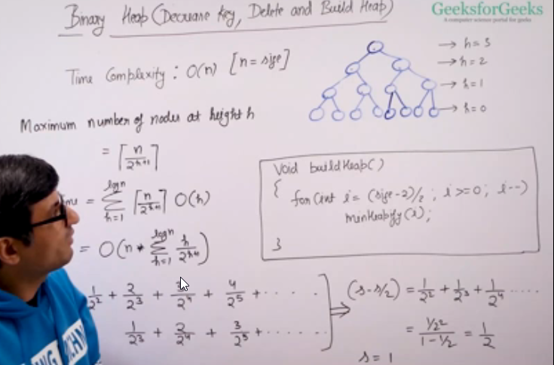

Whenever continuous sorting and other operations are involved, try to apply heap data structure.

Graph

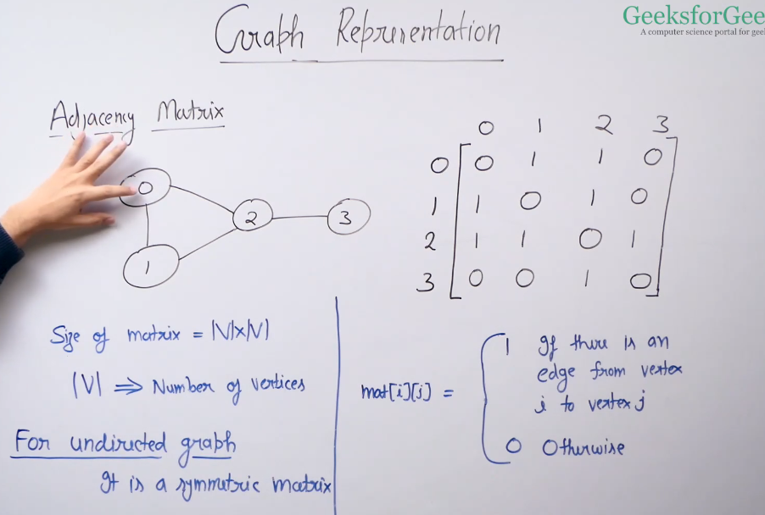

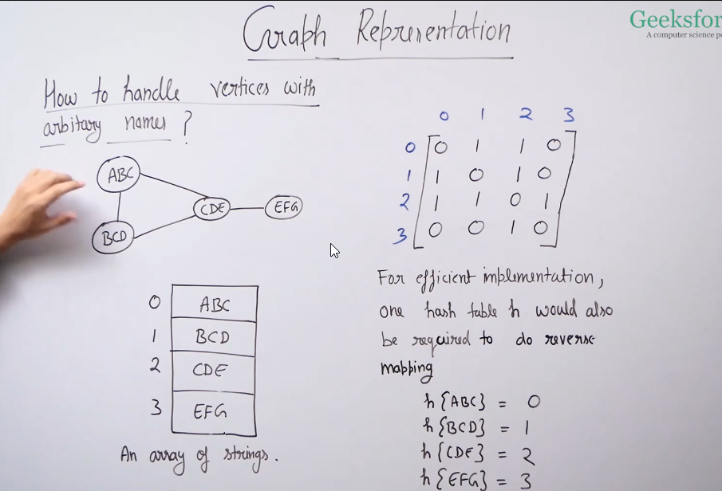

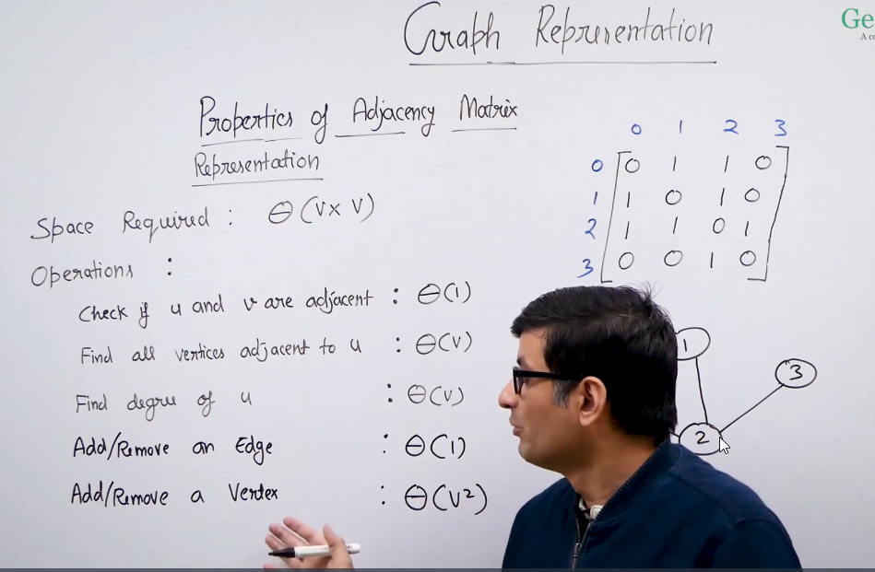

Important question

<https://www.geeksforgeeks.org/batch/dsa-4/track/DSASP-Graph/problem/find-the-number-of-islands>

Detect cycle in directed graph

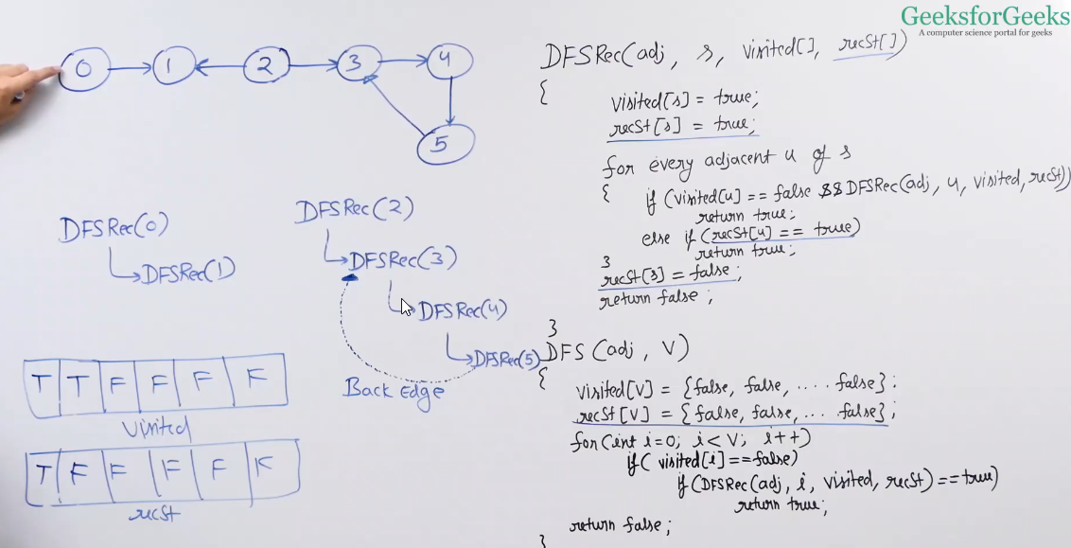

Topological sorting(Kahn’s Algorithm)

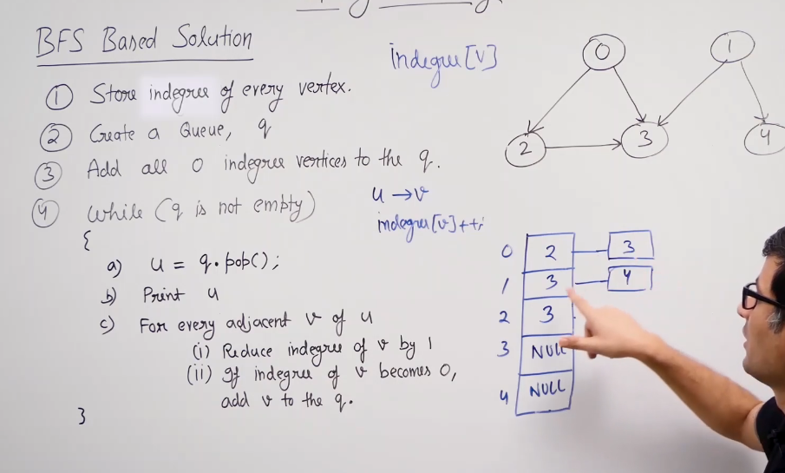

IMP ques

<https://www.geeksforgeeks.org/minimum-number-swaps-required-sort-array/>

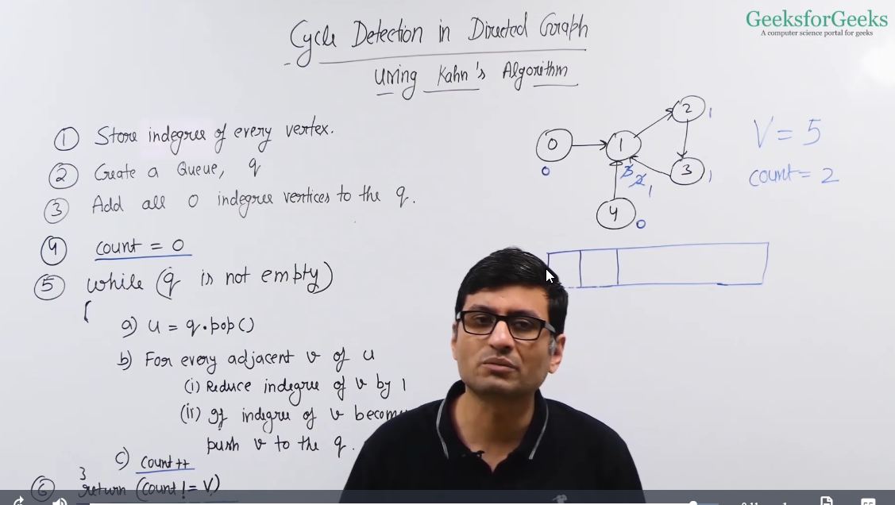

Shortest Path in DAG(Direct Acyclic Graph)

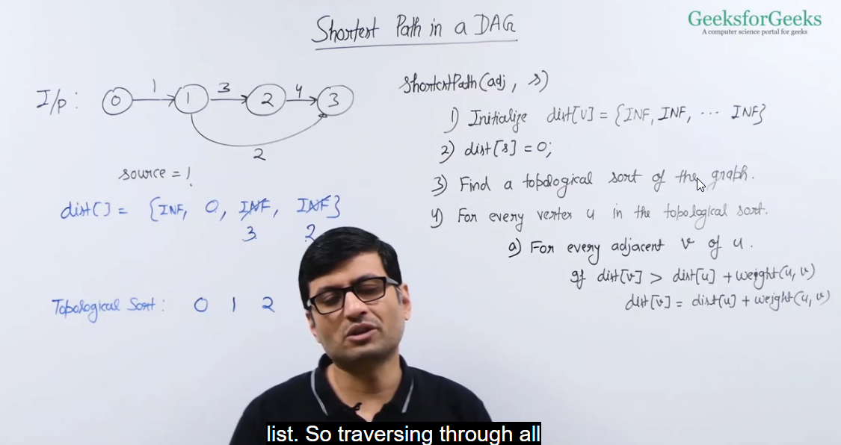

Prims Algorithm implementation

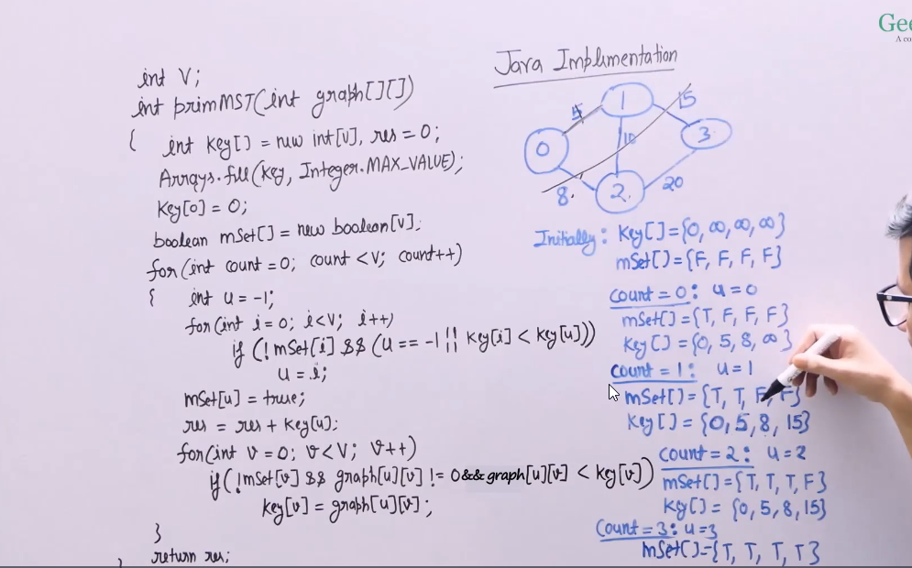

Kosaraju algorithm for strongly connected components(components which are reacheable from each other)

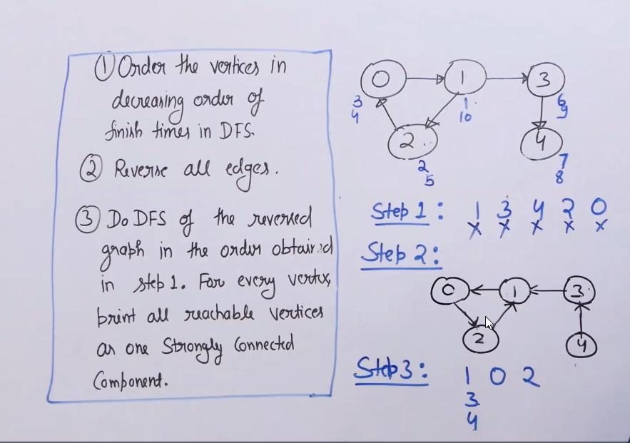

Important question(graph)

<https://www.geeksforgeeks.org/batch/dsa-4/track/DSASP-Graph/problem/bridge-edge-in-graph>

Refer striver video

<https://www.youtube.com/watch?v=qrAub5z8FeA&t=851s>

<https://www.geeksforgeeks.org/batch/dsa-4/track/DSASP-Graph/problem/articulation-point-1>

<https://www.geeksforgeeks.org/tarjan-algorithm-find-strongly-connected-components/>

<https://www.geeksforgeeks.org/strongly-connected-components/>

Greedy Algorithm

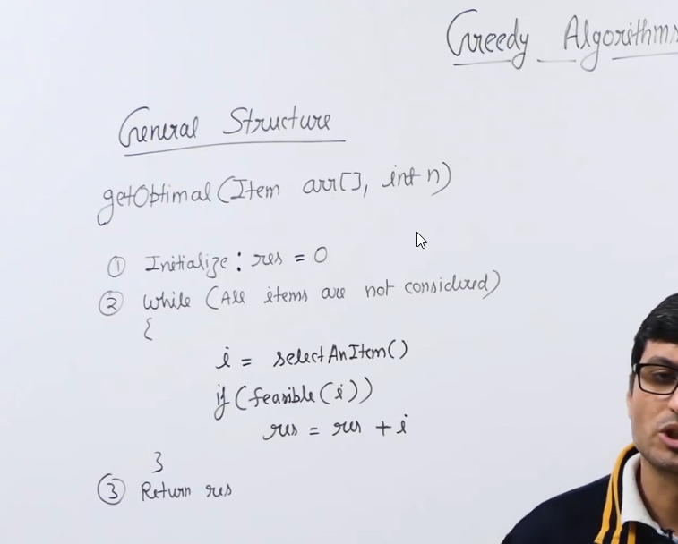

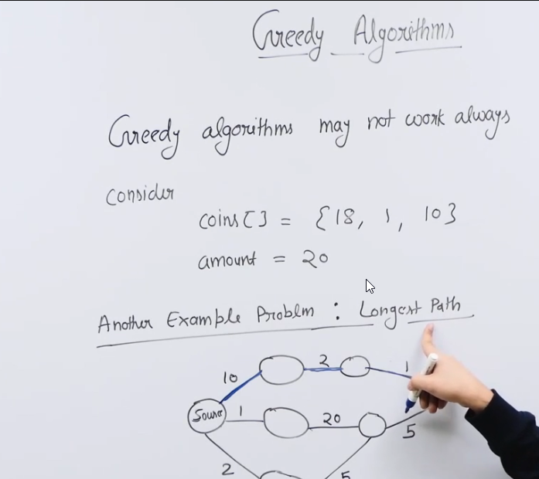

Greedy algorithm may not always work like in case of longest [ath problem , we pick path based on starting highest value i.e out of 3 paths we pick 10 th one , but actually longest path is second one i.e 20th one

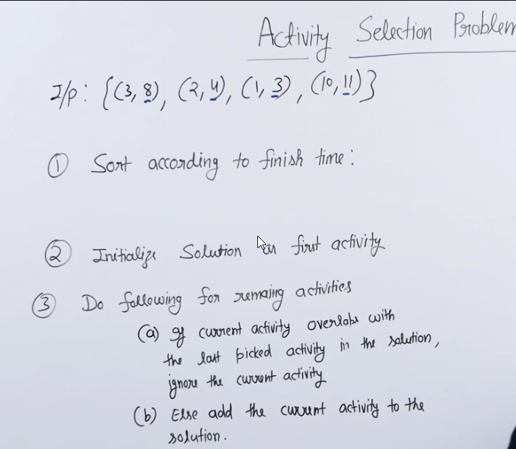

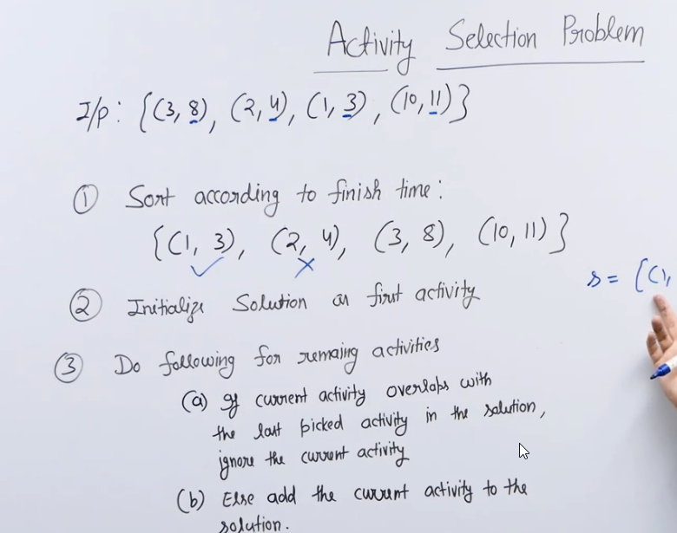

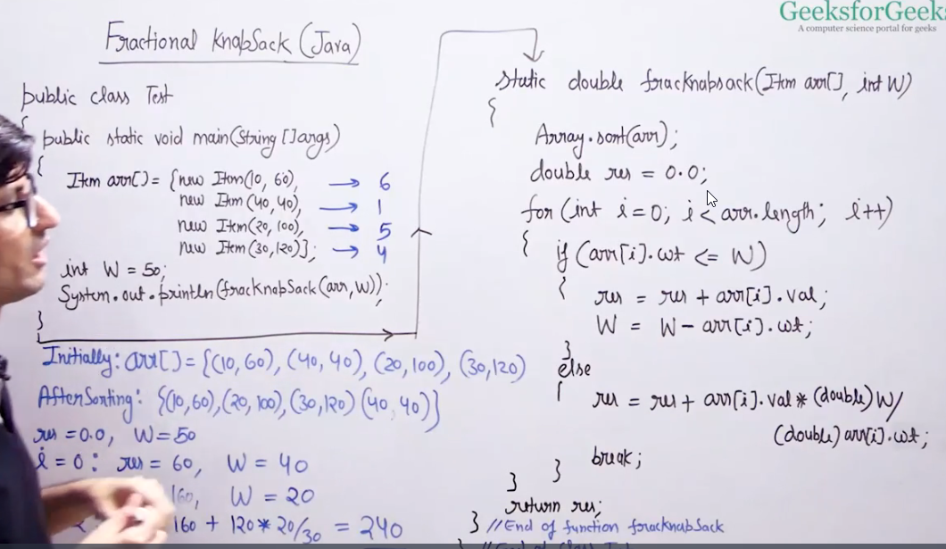

Important problem

<https://www.geeksforgeeks.org/batch/dsa-4/track/DSASP-Greedy/problem/job-sequencing-problem-1587115620>

Trie

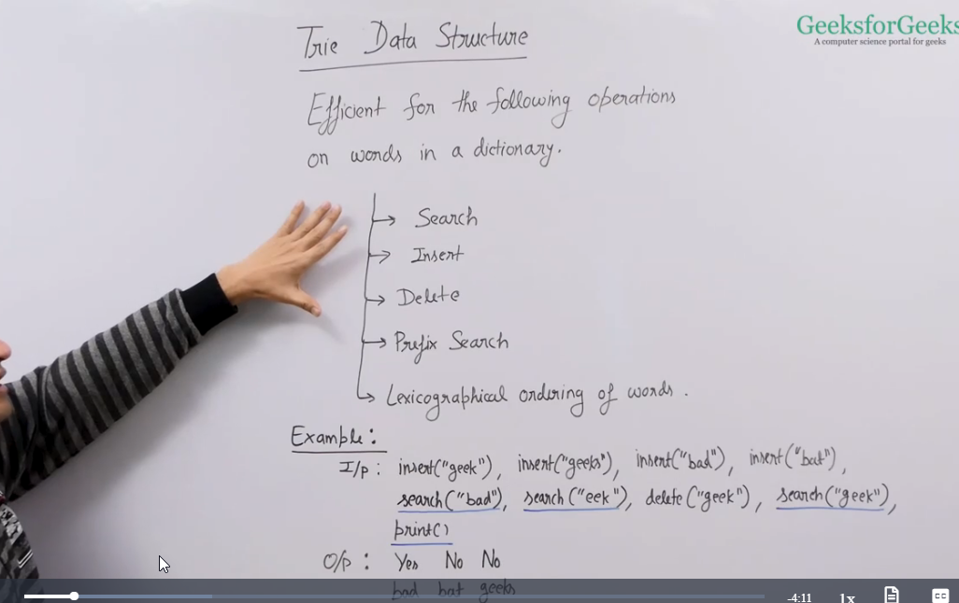

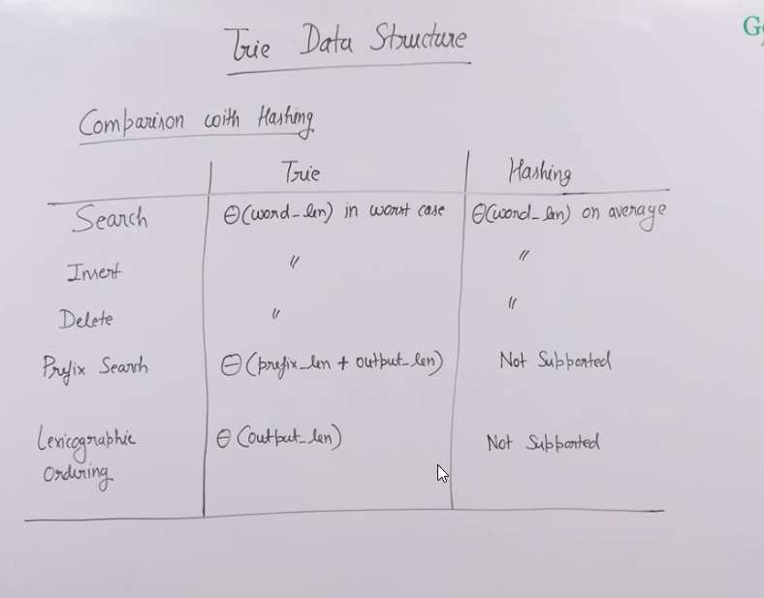

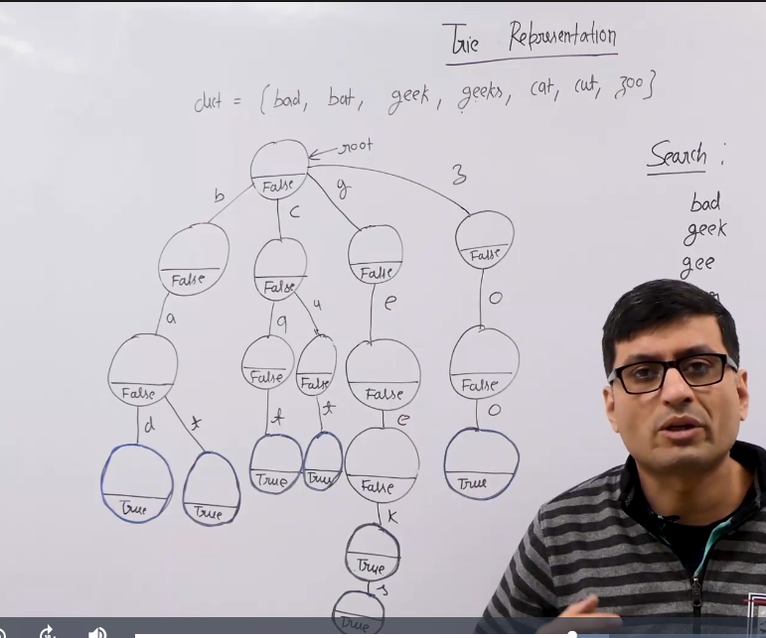

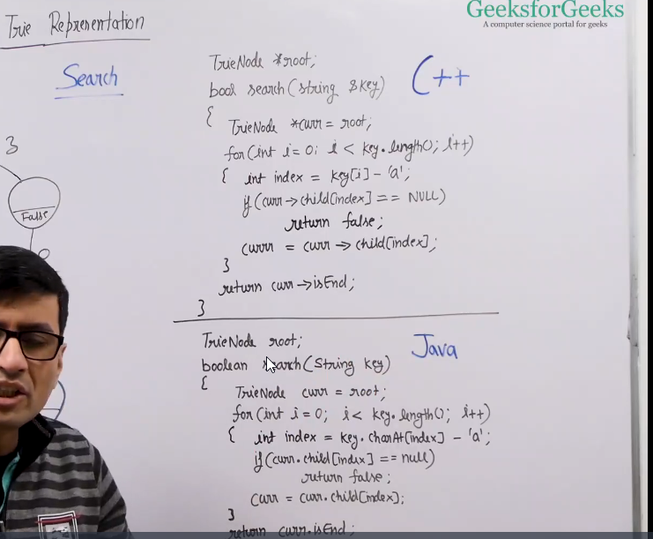

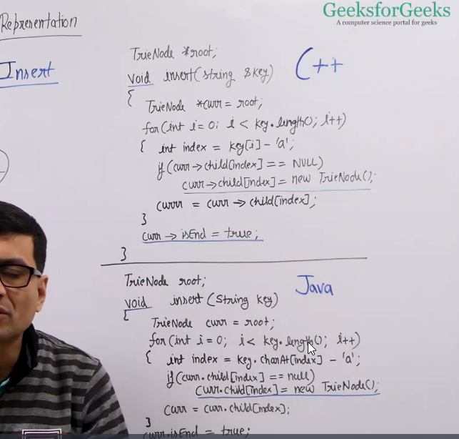

Delete in a trie

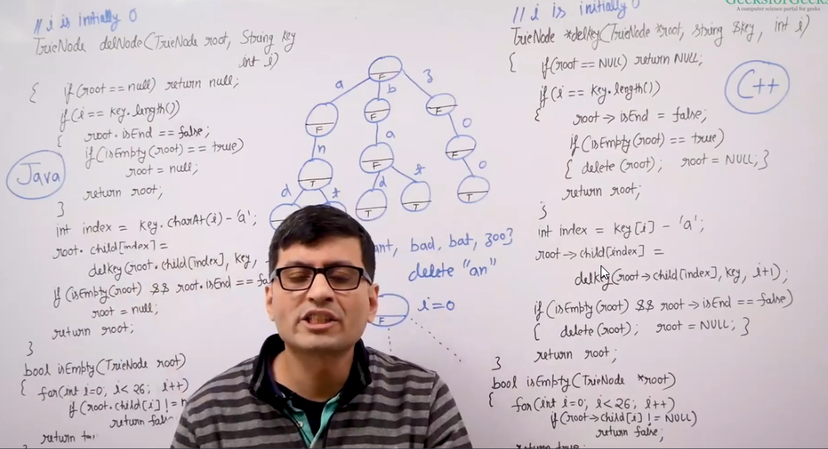

Count Distinct Rows in a Binary Matrix

**Count**

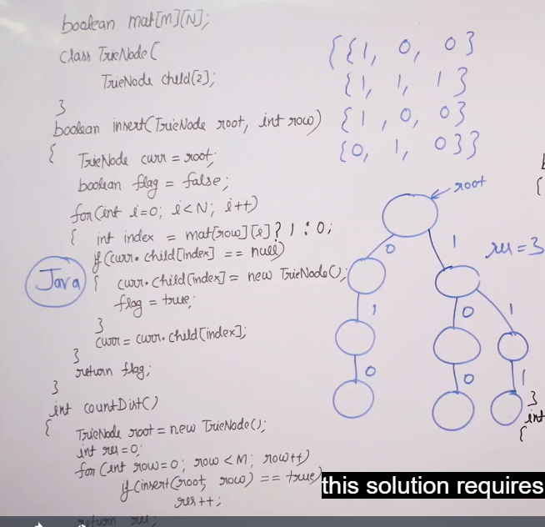

Dynamic Promgramming